POLITECNICO DI MILANO



DIGITAL INNOVATION LAB 2020-2021

prof. Marco Brambilla

**DELIVERABLE 12**

**Polinotes**

**Group ID**

**10**

**Deliverable Title**

**Data Polinotes**

**Team Member**

|  |  |  |
| --- | --- | --- |
| **ID** | **Surname** | **Name** |
| **10803610** | **Morelli** | **Gabriele** |
| **10581051** | **Dossena** | **Simone** |
| **10632820** | **De Guzman** | **Gian Alessandro** |

**Index**

**1) Specifications** **3**

**2) Personas** **5**

**3) Thinking hats** **8**

**4) Value Models** **12**

**5) Customer Journey** **16**

**6) Goal Poster** **19**

**7) BPM-BPR** **21**

**8) User interaction and user interfaces** **24**

**9) Information System & Enterprise Architecture** **29**

**10) CRM & Recommender System** **36**

**11) Data Layer** **41**

***TITLE: DEL.12 - Polinotes***

***SCENARIO: University Life***

***PROBLEM: Lack of proven and complete study material***

***AUTHORS: Gabriele Morelli, Gian Alessandro De Guzman, Simone Dossena***

# 1) Specifications

1. **Context**

One of the most essential parts of the society is the education, especially the specialistic knowledge provided by the University Institutions. Currently there are a lot of people investing in their formation in order to have a brighter future.

One of the most relevant parts of university life consists in following the lectures.

During these lessons students are used to take notes in order to follow and have a better comprehension of the treated topics.

Consequently, students spend a lot of time and energy adjusting these notes in order to be able to study from them, making them as comprehensible as possible and this requires the prevailing part of their time.

It comes immediately to the fact that this might be problematic to some categories of students.



1. **Instantiation**

In “Politecnico di Milano” there is a relevant percentage of students who aren’t able to follow the lectures due to various reasons; we may think about working-students, students having a schedule affected by overlapping courses. Moreover, being the Politecnico an international university, with a respectful reputation, many attendees, who live in foreign countries having a different time zone struggle to follow the lessons in presence.



1. **Problem**

The successful preparation for an exam passes through a study on proven material.

Therefore, an additional instrument that can help students to prepare for an exam could be represented by good notes.

In this sense, students have to spend the great majority of their time adjusting their notes.

However, there are students who aren't even able to take notes due to external reasons like working or overlapping courses.

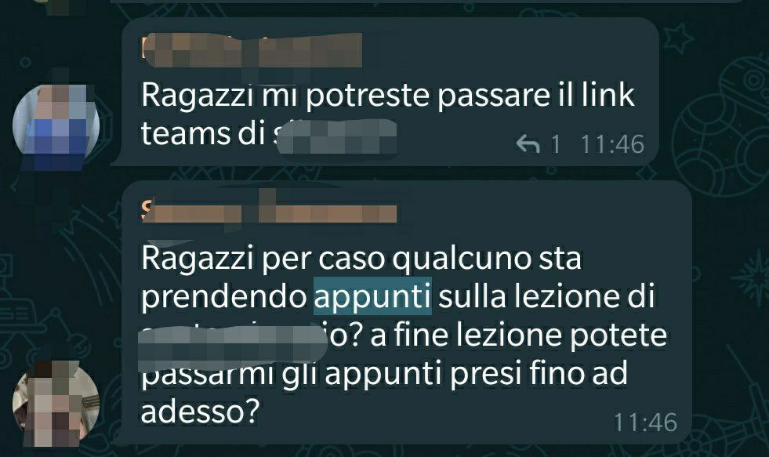

Because of this, students frequently ask for some material from people who, in their opinion, are reliable. Sometimes this procedure could be difficult for some people, particularly in this tough period of pandemic and in any case you can’t be sure about the reliability of the notes that you find either on the internet or by a colleague in the university.

Another important aspect to consider especially in Politecnico where most of the exams are composed of exercises, is that it may happen that some solutions of the mock exercises, that are given to the students to practice for the final exam, are not provided. So students end up spending a lot of time without even knowing if what they are doing is right or not, whether the procedure followed to solve the exercise is the correct one or simply having feedback on the found result.

Considering all of this information about the difficulties that universitary students can have, our goal is to find an instrument that can facilitate the experience of these students in the very important phase of the preparation of the exams.

1. **Stakeholders**

* The customers and the users, are the students of the university who, for different reasons, don’t have the possibility to follow the lectures synchronously and so to take notes; moreover some students could want to exploit their notes to get some benefits.
* Politecnico di Milano could play the role of intermediary in the exchange of notes in order to offer an additional service to the students of the university.

It’s important to consider that the professors aren’t taken into account as stakeholders, since the main problem presented is about student-to-student interaction.

1. **References**

<https://www.polimi.it/il-politecnico/organi/nucleo-di-valutazione/dati-a-cura-dellufficio-di-supporto/>

*-Politecnico di Milano, “Dati quantitativi e indagini occupazionali”*

<https://ricerca.repubblica.it/repubblica/archivio/repubblica/2017/02/21/appunti-condivisi-nasce-un-sito-per-studenti-lavoratoriPalermo04.html>

*-La Repubblica, “Appunti condivisi, nasce un sito per studenti lavoratori”*

<https://www.researchgate.net/publication/235221548_Shared_note-taking_a_smartphone-based_approach_to_increased_student_engagement_in_lectures>

-*ResearchGate, “Shared note-taking: a smartphone-based approach to increased student engagement in lectures”*

<https://www.insidehighered.com/news/2009/08/05/taking-notes-beyond-classroom>

*-Inside Higher Ed, “Taking Notes Beyond the Classroom”*

# 

# 2) Personas

**2.1. Working Students**

**Giancarlo Fumagalli** is a working student who wants to complete his studies. Being very busy with his occupation, he doesn’t have enough time to keep up with lessons*.*

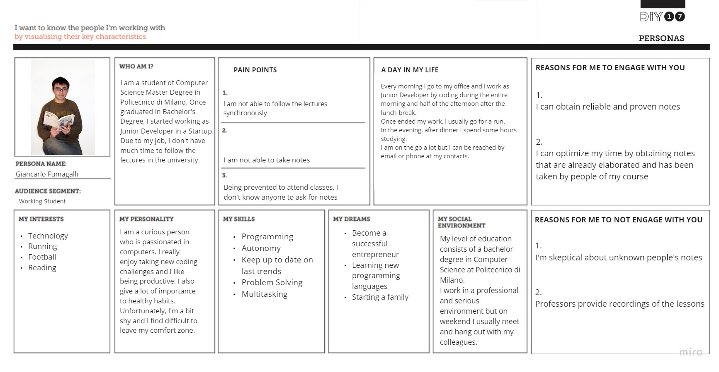

**2.2. Abroad Student**

**Ishwar Kontrappali** is an off-site student who struggles to follow the lesson synchronously and get acquaintances with his classmates.

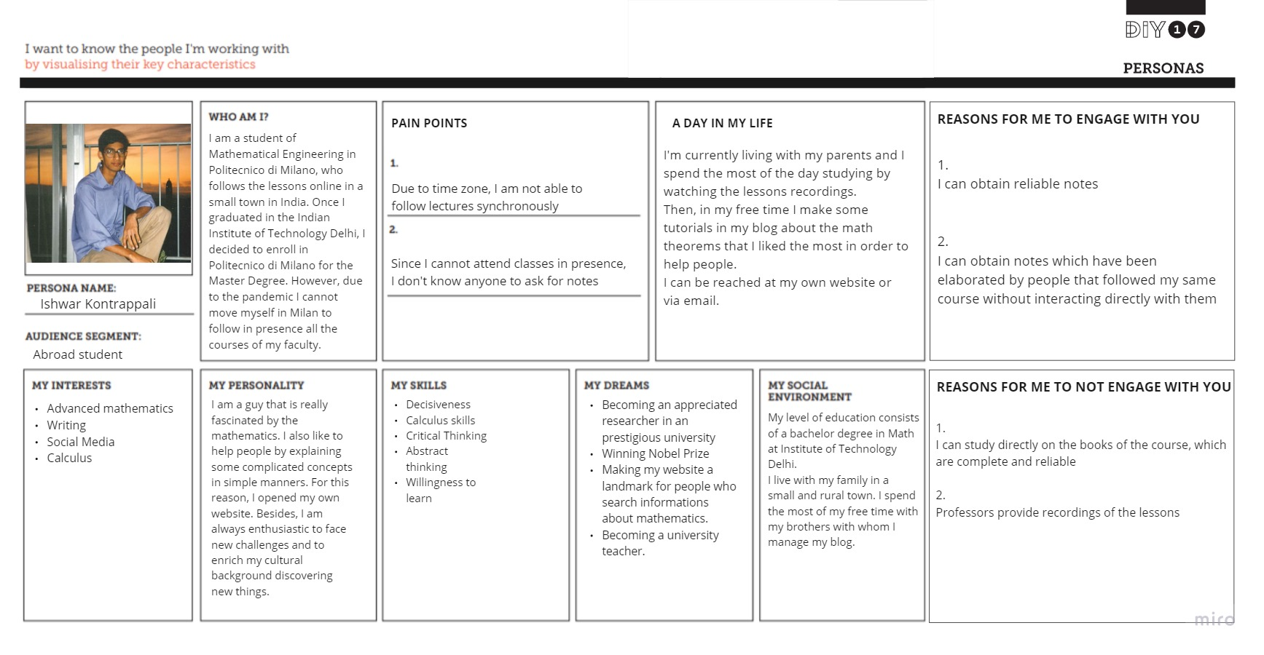

**2.3. Responsible Student   
Marcello Cancelli** is a responsible student with a good business attitude who would like to help other people and who is looking for opportunities to make some extra money.

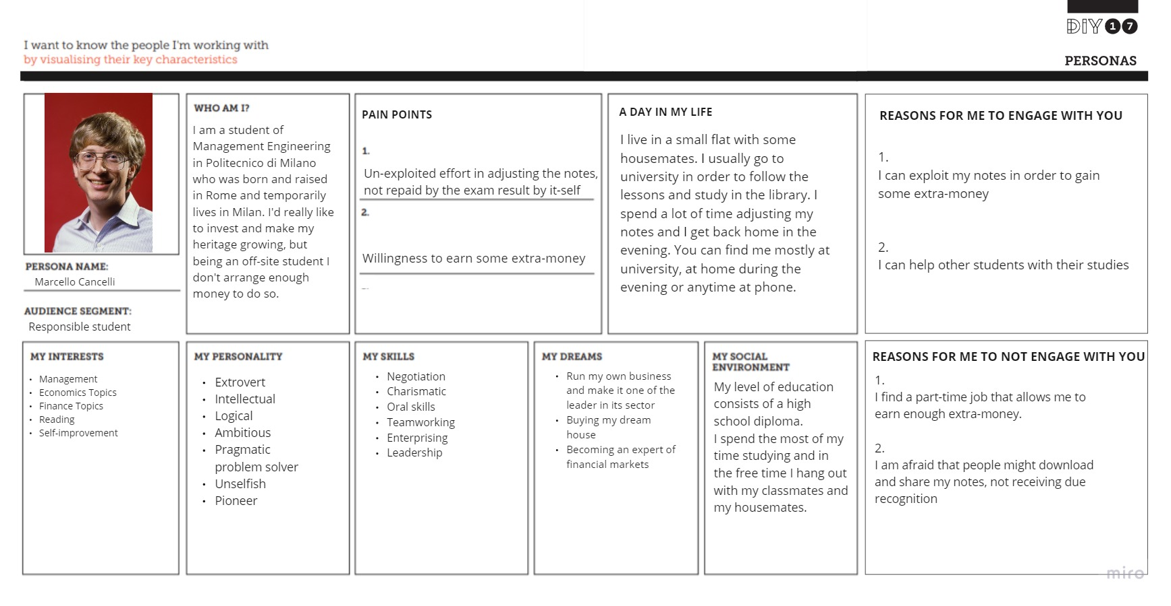

**Sakai Persona Map**

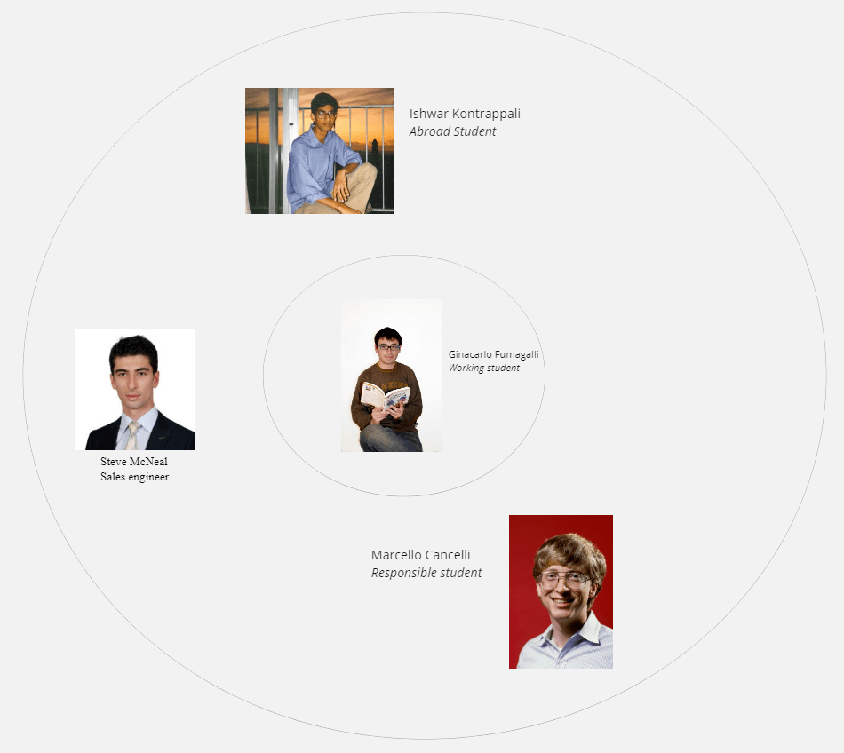

The primary persona on which we mainly focused is the working student, in our work is represented by: Giancarlo Fumagalli.

We wanted to meet his needs first because the working students are a relevant percentage in the University environment so it would be great if the University would be able to offer them a better formative service.

Another aspect of the University environment is represented by the foreign students. This is impersonated by Ishwar Kontrappali.

We decided to look at him as a secondary persona because his problem is mainly due to the tough pandemic period we are experiencing. However, the social implications brought by this new challenging situation might be a starting point to enhance the services offered by the University.

Moreover, since every problem can be seen as a new opportunity, we opted for Marcello Cancelli as the representative of the enterprising student who wants to earn some extra money. This would be great for many students since a lot of off-site students, but actually all the students in general, live mainly with parent's money. We opted for Marcello Cancelli as the representative of this audience segment and we put him as a secondary person since we want to focus on the solution of notes taking problems and not on the possibility of earning money through it.

As the radar above shows, we have inserted another persona that has not been described before.

Steve McNeal represents an additional persona that was considered while going on with the work.

Steve McNeal is a sales engineer that works for the platform.   
He has technical tasks in the startup as the improving and the maintenance of the recommender system including the monitoring and the preparation of the data.   
Steve was born in England, he attended the University of Greenwich for its bachelor degree in Computer Science Engineering and then decided to complete its studies with a master degree in Management Engineering in Politecnico di Milano. Once he finished its studies, he decided to remain in Italy for his career, so after 4 years in a local company in Milan, he was called to join our startup with the role of Sales Engineer.

# 

# 3) Thinking hats

**Phase 1: each member wears a different hat**

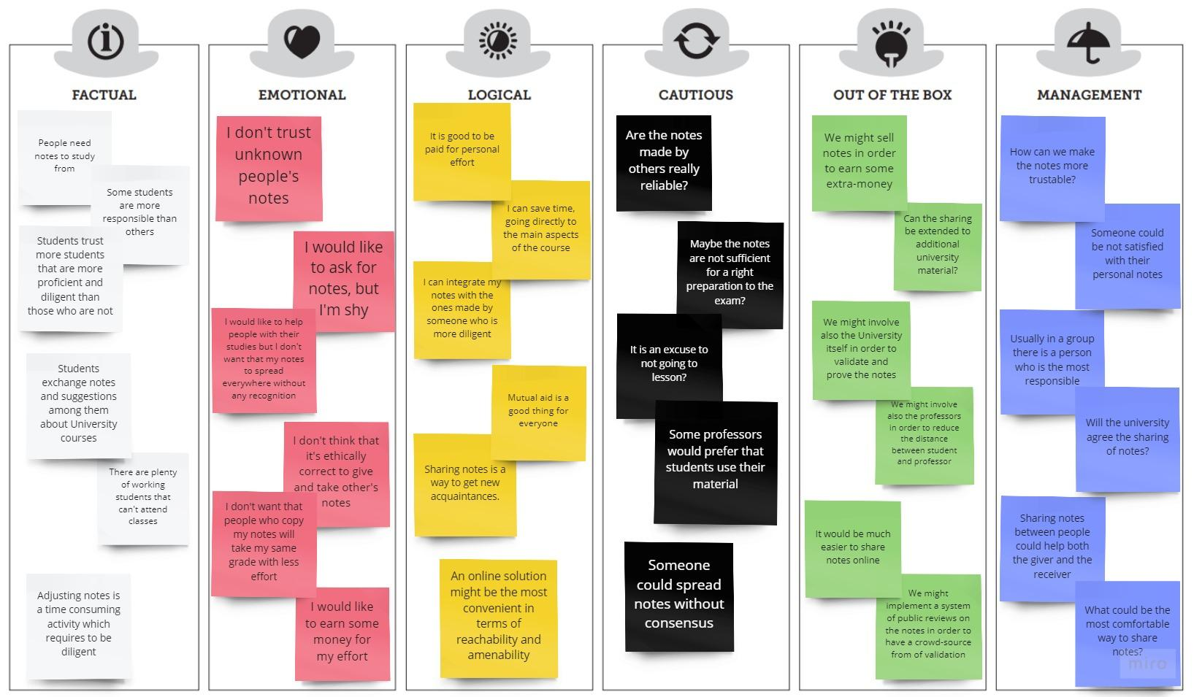

Sharing notes is an instrument that could give a lot of benefits to the students. Indeed, people that are busy could save some time instead of wasting it by adjusting their notes and others would get repaid for their efforts not only with the grades but economically as well. However some people may not trust unknown people's notes so a review rate system would solve the problem.

**Round 1**

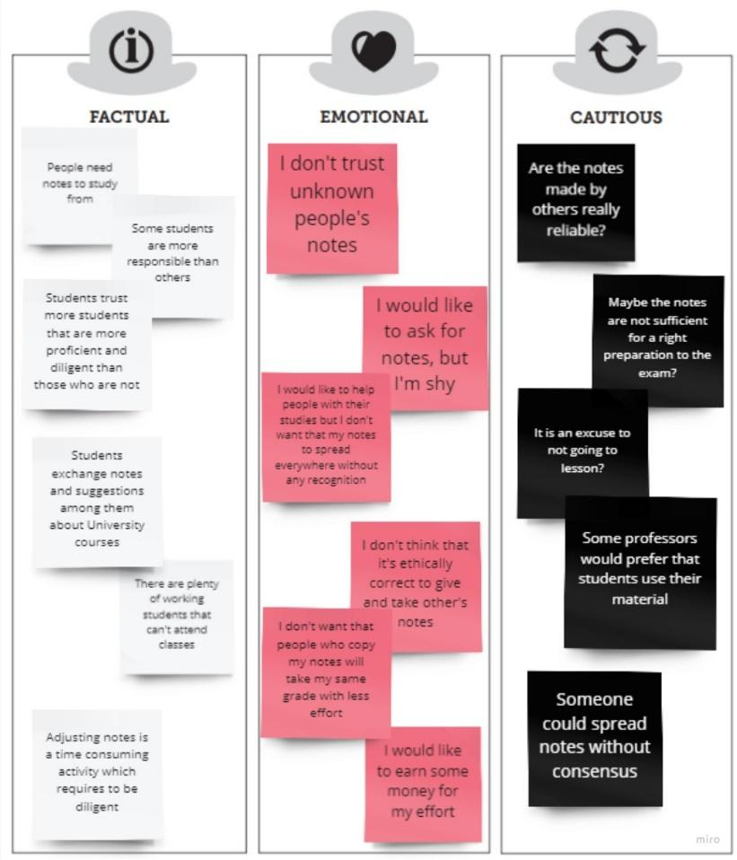

During the first round, the Thinking Hats worn were the factual, the emotional and the cautious one. The first topic highlighted by the factual hat was the utility of having some material already elaborated by some students, underlying that some sources are more reliable than others. The emotional and cautious hats manifested their doubts about it: the red one more in a personal perspective while the black one regarding the general problem of trustworthiness of information on the internet.

The discussion continued with the fact that students in any case exchange university material; so, the red hat replied, discussing that shy people might be uncomfortable in sharing their personal elaboration of the notes. However, the black hat alluded to the fact that having already prepared material might end-up in being an excuse to not follow the lectures or even worse, might result in being not enough prepared since trusting someone else's notes won't ensure you that the material is complete.

Finally, it has been discussed how much "adjusting notes" is a time-consuming activity which could be rewarded maybe through earning some extra-money.

**Round 2**

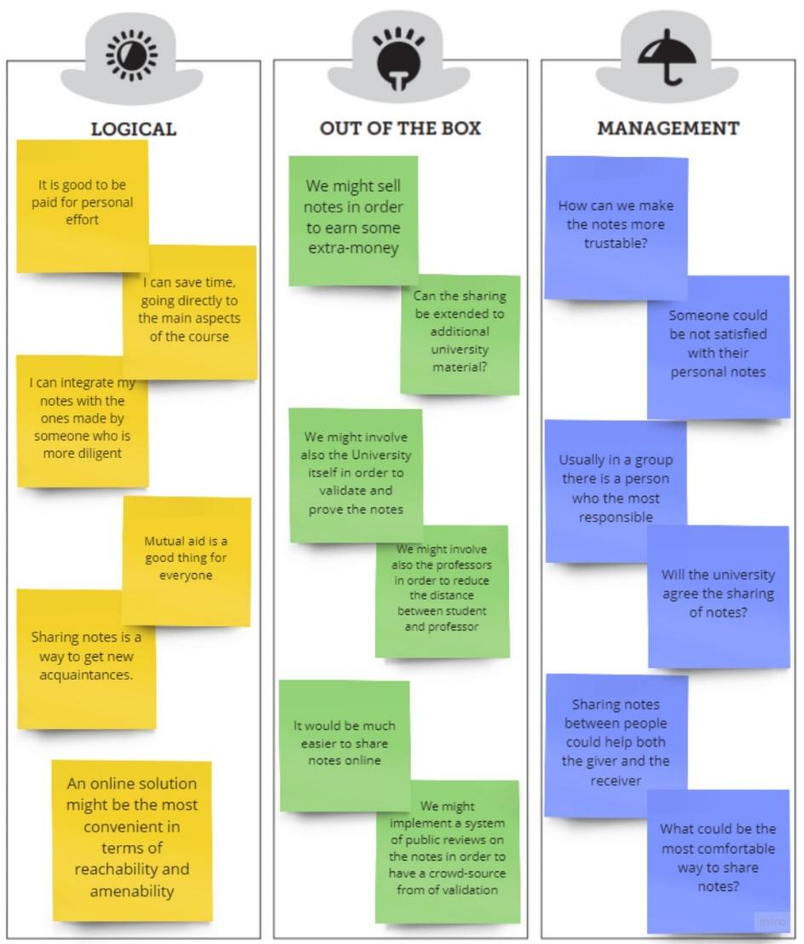

During the second round, the thinking hats that were involved are the logical one, the out of the box one and the management one.

Everyone agreed that sharing notes can bring a lot of advantages to the students, both to the receiver, who saves time, and the giver, who can earn some money and maybe some new friendships could be born as well. Furthermore, an online tool could be a comfortable solution.

Then, the discussion was led by the green hat that proposed new ideas and solutions such as the use of an online platform for an easier sharing of notes or a system of reviews to underline the reliability of the notes. The green hat and the blue hat agreed on those ideas.

**Phase 2: everyone wears the same hat**

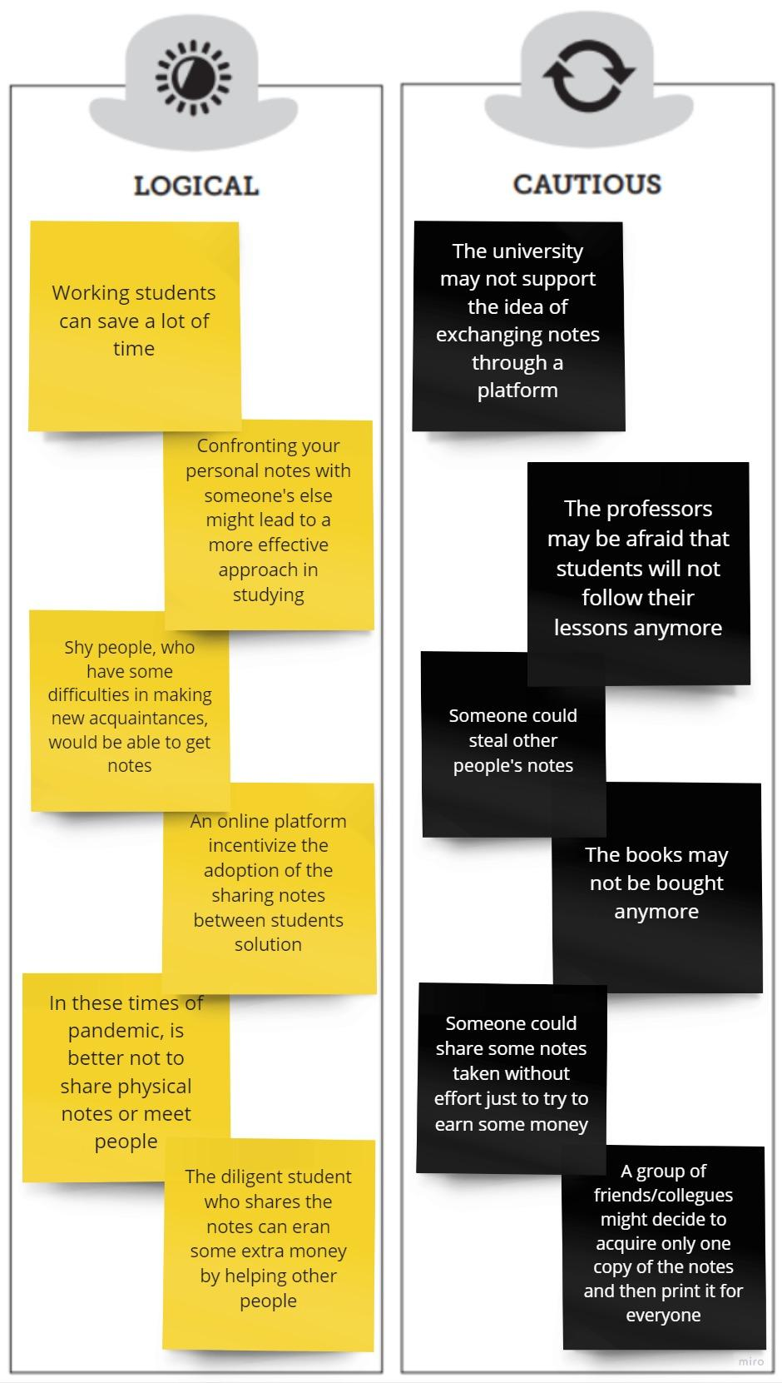

In the second phase we changed the worn hat, wearing the respective one: the cautious hat.

In this phase the main issues that emerged were about the fact that some professors or directly the entire University might not support this idea since the reference books of the courses may not be bought anymore or would affect the fact that, having already the material, some students might decide to not follow some courses .

Then we discussed the problem of sharing notes. Someone could share some notes taken by others, pretending to have the property, in order to earn some money or that a group of friends/colleagues might decide to acquire only one copy of the notes and then print it for everyone.

# 4) Value Models

**Brainstorming**

The exchange of ideas has been generally calm and peaceful, where the opinions of everyone have been respected fairly, this approach helped in creating a very challenging and constructive environment.

In some cases there have been some discussions about whether buying personal notes is ethically correct. Some members thought that it could benefit lazy people who would eventually don't follow the lessons, not respecting their duty. Then the proposer of the idea convinced the colleagues by saying that some students may have some difficulties in taking notes because of lacking time. The reasons may vary from work to the fact of living in another country with a different time zone.

Finally some ideas have been discarded because they were focused on aspects deemed out of scope with respect to the core of the problems.

|  |  |  |
| --- | --- | --- |
| **Idea** | **Who** | **Feedback** |
| Sharing notes in a website | Gian﻿ | This has been one of the proposed solutions to the problem that some students may have difficulties in taking notes. Since every member agreed positively on this idea, realizing the advantages in terms of usability and amenability we started the development of this possible solution.﻿ |
| Let the buyers of the notes review the notes | Simone | One member didn't like this idea because he was afraid that someone could review some notes without effectively checking the notes. Then he was convinced by the fact that the reviews were allowed only by the users who actually bought the notes. |
| You have to pay in order to leave a rating﻿ | Gabriele | This idea, after having been evaluated with respect to other proposed solutions has been discarded due to its excessiveness: no one would have paid to leave a rating. |
| Sell notes for money﻿ | Gabriele﻿ | Some members of the group were a bit skeptical about it, since we didn't want to make money instead of actually helping other people. This concern was then abandoned in favor of implementing a system based on buying and selling in order to reward the effort. |
| Portal extended to books﻿ | Gian﻿ | The idea was discarded because we realized that there are several tools for sharing books, so everyone agreed that it would be better to concentrate only on the notes. |
| Teachers can upload their personal material﻿ | Gian | One member of the team wasn't so convinced on this aspect because he thought that the material uploaded by the professor, being the most reliable, will be the most downloaded. However, the idea was accepted when the other members stated that maybe not all the professors would share their material in the platform and in any case someone could be more interested in the material uploaded by a student because in that case the topics could be elaborated in a manner that is easier to understand for other students. |
| Ask for sponsorship of Politecnico di Milano | Simone﻿ | Everyone agreed on this idea realizing that the University could be interested in offering a new and useful service to its students. |
| Developing a mobile app﻿ | Gabriele﻿ | This idea has been chosen since it could help in the adoption by the students of this solution. |

**Fast Idea Generator**

We started by clearly defining the problem that there are some students that may have difficulties in taking notes. Then we started stretching the thinking around this idea in different directions. To do so we thought to use the nine challenges suggested by the template.

During the discussion, we didn't discard any idea, from the most creative, such as contests to incentivize the usage of our solution or supposing that it would be possible to pass an exam without studying, to the most interesting ones such as having reliable material that has been taken by reliable students and which might be proven by the University itself.

Finally, we reviewed all the ideas by choosing those that were more interesting and that may bring more value to our solution of having a platform of sharing notes tailored exclusively for the Politecnico di Milano. The stars in the table are meant to indicate the points that we consider the most significant ones.

**The problem is *that some students may have difficulties in taking notes***

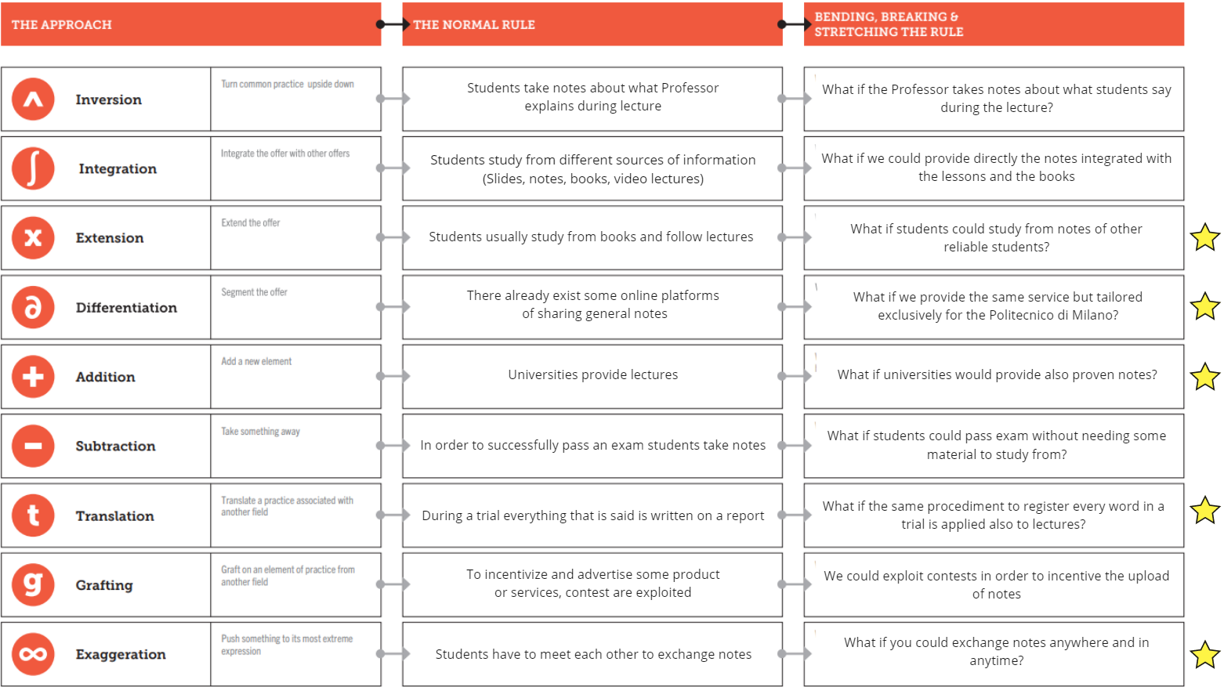

**SWOT Analysis**

Our solution of exchanging notes online would be the first one to be affiliated by the Politecnico di Milano for its students. To perform this analysis, we have considered both the features of the solution and the characteristics of who potentially is going to develop the proposed solution. The stars in the table are meant to indicate the points that we consider the most significant ones in that part of the SWOT analysis.

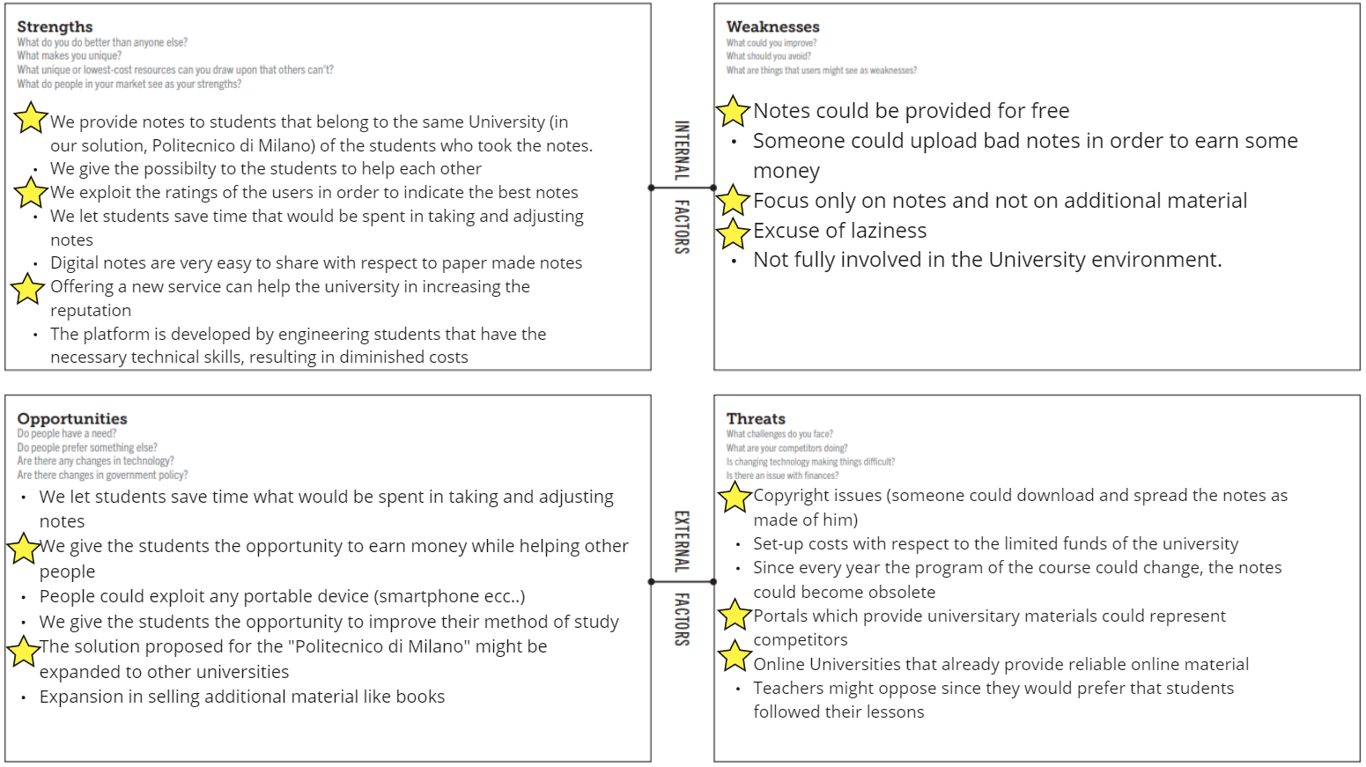

**Promises & Potential Map**

To better understand how to position our solution, we decided to analyze it from two different perspectives. Since there already exist other portals that provide universitary materials, such as Studocu and Andreadd, we can define the idea of sharing notes as an existing offer addressed to existing users. Practically speaking, if we think about some technical features that composed our solution we can say that actually they represent something that already exists because they have been already implemented in similar portals (for example a rating or review system on notes shared on a platform) and also to existing users because maybe some students already use the mentioned portals.   
However, in the overview of the Politecnico di Milano, that is the university involved in the project, the solution stands as a new offering because Politecnico doesn't provide a similar service for its students. For the same reason, the attendees of the University can be seen as new users. The point here is that having a solution directly offered by a University is something which did not exist before; indeed having directly the university involved in this service enables the platform to benefit from its reliability. The solution is tailored in the sense that we for example directly utilize the credentials of the Politecnico to login in the platform.   
Another feature that we can consider as evolutionary is the fact to assign a label of “Trusted” to users that ,according to some parameters about interactions with the platform, have shown a particular commitment. This label can be very important to them making their uploaded notes 100% trusted and provable leading them to be more frequently downloaded.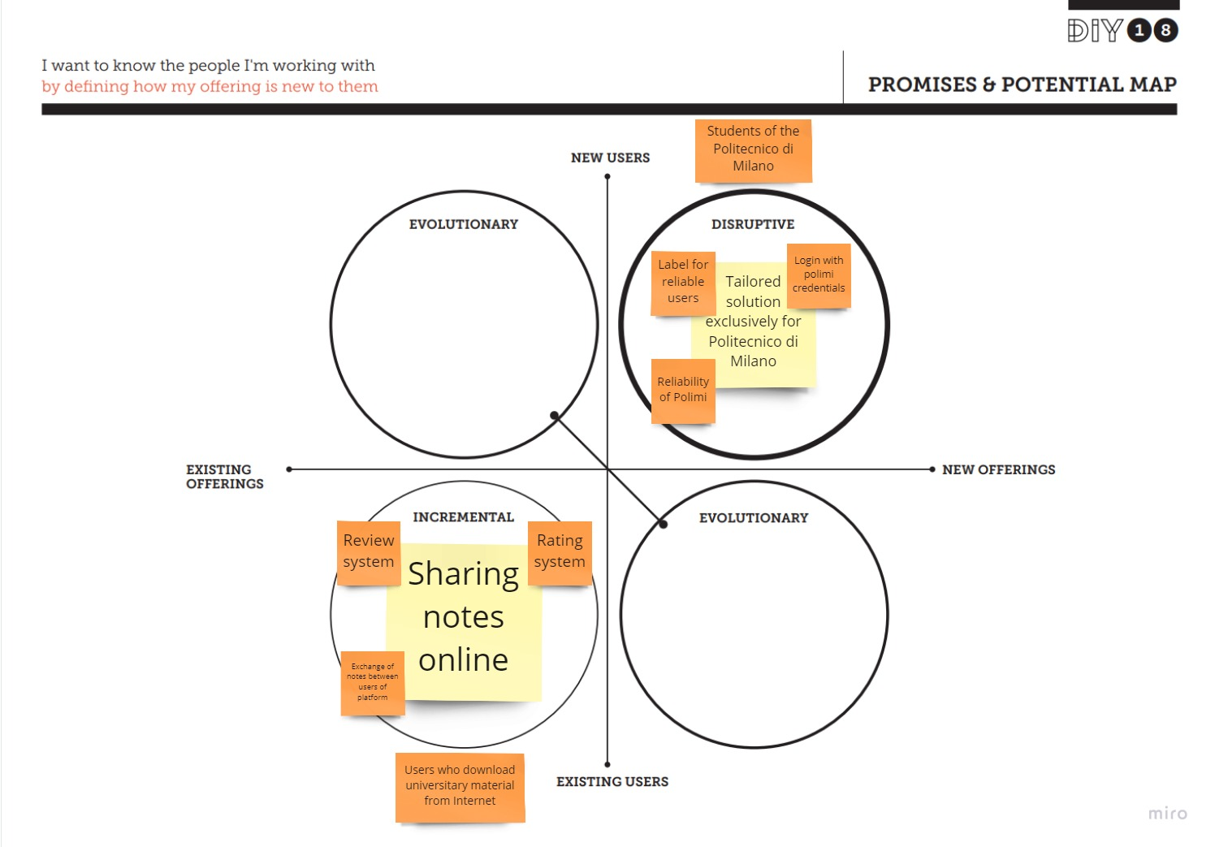

# 

# 5) Customer Journey

1. **Persona selection**

As the persona we chose Giancarlo Fumagalli, a working student who wants to complete his studies but is very busy with his job. We decide to consider its persona because it probably represents the greatest slice of students that will benefit from our solution.

1. **Portion of lifecycle selection**

We chose to analyze the first part of the life cycle, buy (market & sell), because it was more relevant with respect to our solution and the selected persona. His paint points were indeed more connected to the need for reliable notes, so we concentrated on the upload/download part.

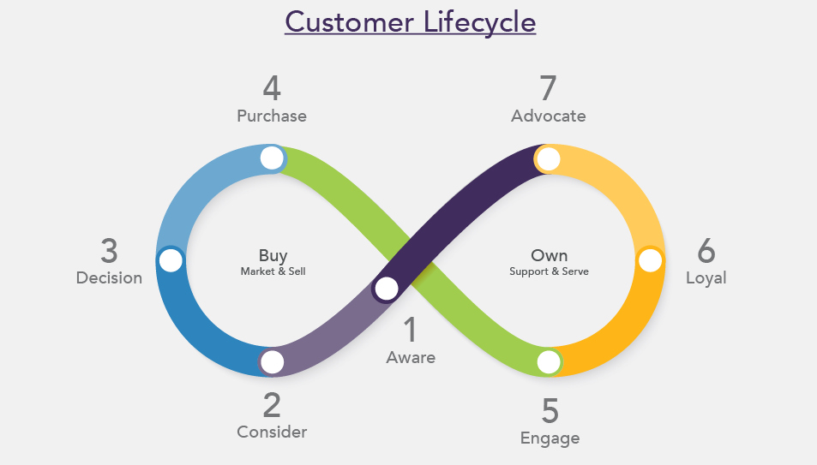

1. **Behaviour Line**

We reduced the behavioural line to seven main steps(dark green) highlighting the most relevant points of our solution. Since our persona is a working student he struggles to keep up with the program of the course since he has to work during lesson time. He finds out about the platform to share notes on the website of the University. Once he appreciated the service by looking at the statistics and so, finding it actually useful and trustable he decided to register using the Polimi credentials. Then he browses the website, searching for his course and filtering by year and professor in order to find the notes of the missed lessons. Once found, he decides to choose the notes with the best ratings and more explicative reviews. Finally, he makes the purchase and downloads the notes.

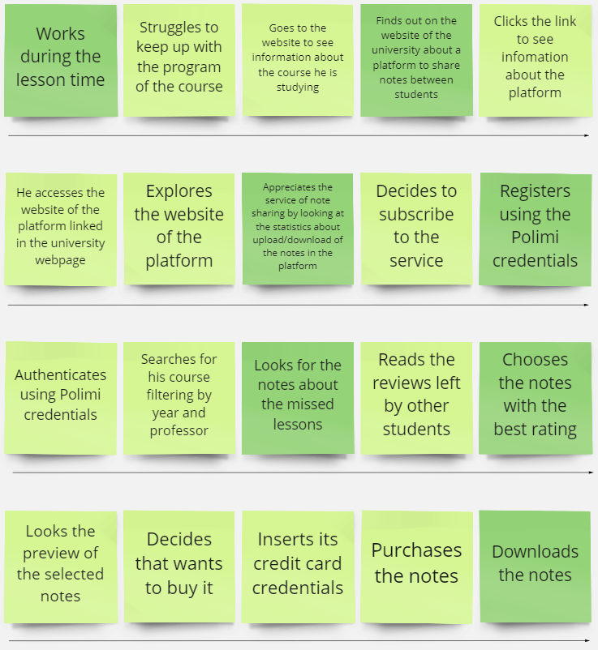

1. **Customer Journey Map**

Regarding the customer journey map, we started by thinking of possible channels whereby the user can become aware of the product. Being the solution tailored for the Politecnico di Milano and mainly used by the students of that university, the main way to discover the platform is the advertisement on the webpage of the Politecnico. Regarding the consideration phase, we realized that the registration would be the key phase in which the user thinks about the solution. We thought about the possible aspect of the registration or other external elements as a banner to encourage the user to adopt the solution. For the onboard part, we considered the time in which the user, once registered using his universitary credentials, can decide to use the application (so upload or download the notes). We concentrate on the aspects of the product that could enable a better experience for the users. Finally, for the convert and retain phase, we studied the phases in which the user really interacts with the platform by downloading or uploading notes and the phase subsequent to it. Then we concentrated on the aspects that could convince the user to re-use the application in future. For all the parts of the customer journey, we also analyzed the possible critical aspects, the metrics to understand which parts are better and which ones can be improved and hence the concrete improvements that could be imported to the solution.

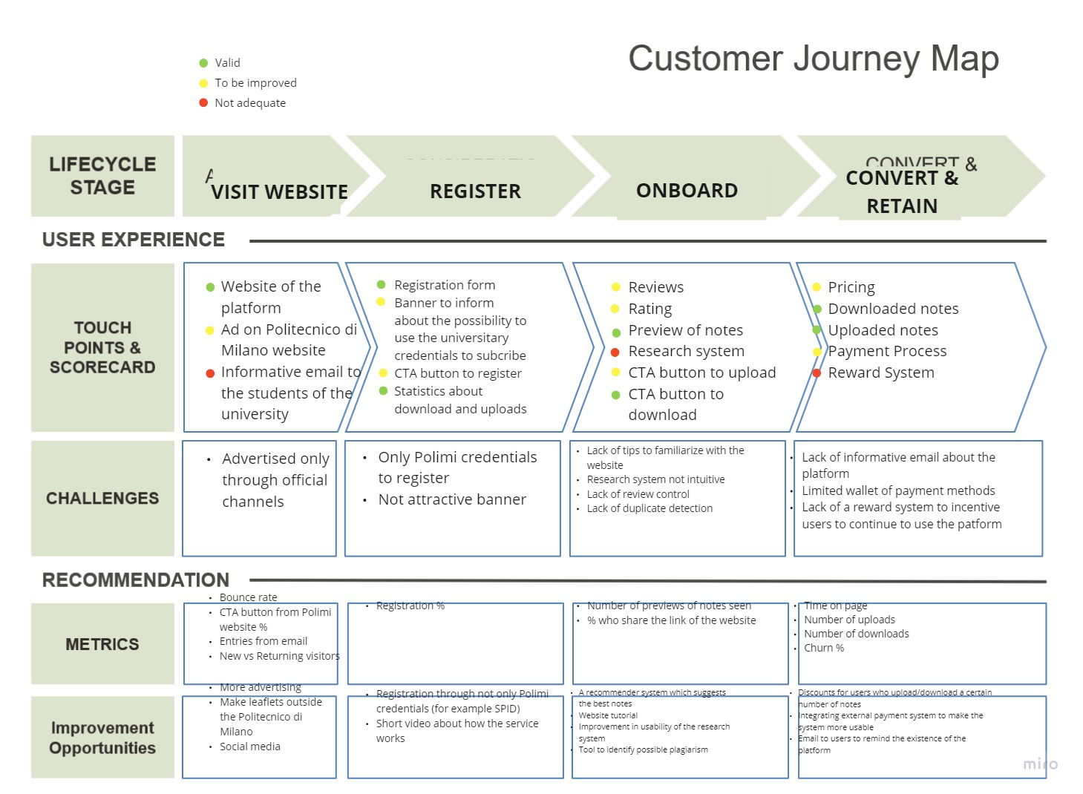

# 6) Goal Poster

**Goal Poster 1**

For this goal poster, we consider Steve McNeal, a sales engineer that has the task to monitor the state of the application and to take actions in order to improve it by amending the recommender system of the notes for the platform. In this case, he realized that a key for the success of the application is represented by the ratings. For this reason, the goal is to keep in the application a high percentage of left reviews.

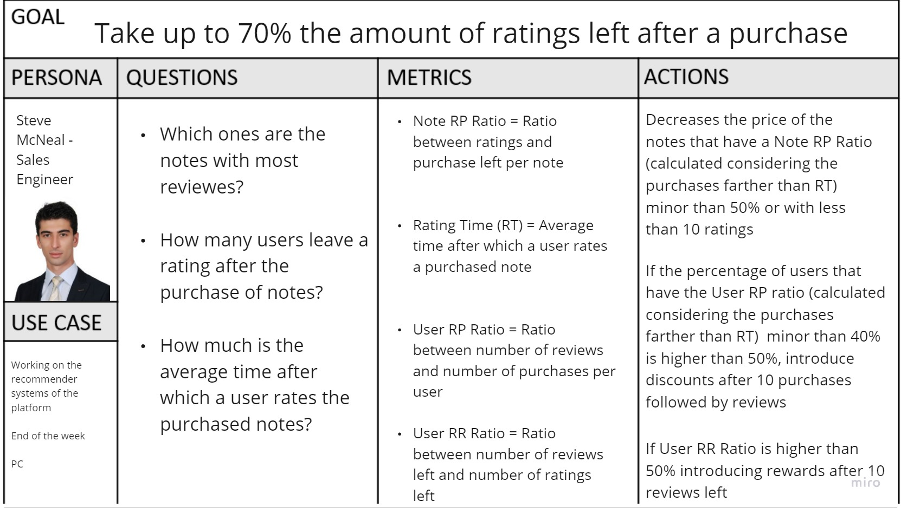

**Goal Poster 2**

In this goal poster, the focus is on the quality of the material uploaded in the platform. To achieve the success of the platform, it is important to keep the quality of the notes as high as possible. We describe the experience from the point of view of a user of the platform, Ishwar Kotrappali, a master degree student of the Politecnico di Milano who for pandemic reasons is not able to move from his country (India) to Milano. Therefore he is unable to follow the lesson in presence and look for the notes on the platform, hoping to find high-quality notes.

# 

# 7) BPM-BPR

**BPMN 1 - Customer purchases notes**

The first situation we decided to represent is the one in which a student of Politecnico di Milano, once logged in using his universitary credentials, starts the process of selection, evaluation and purchase of notes. The actors of this scenario are the customer (the student), the system of the platform, the bank to control the payment credentials (that we will consider as a black-box) and the website of the Politecnico that checks the credentials and then redirect to the website of the platform if the credentials are correct. Once the user received the home page of the website of the platform, he started to search notes using the dedicated form (we model it as a subprocess that is visible above the 4 pools). After the user submitted the form, the system provides the suitable notes ordered by decreasing ratings. At this point the user can evaluate the notes he received, can see the preview and then can decide to purchase it. In that case, he has to insert the payment credentials that will be sent to the system that forwards it to the bank to check their validity. If the credentials are correct, at the end the user will receive the purchased notes otherwise he has to reinsert the credentials.

We chose this situation because it represents the core of our solution (together with the upload process), it is also interesting because it allows us to see the various interactions between different parties involved in the system.

For the description of the process, we consider the case in which the user is able at the end to purchase the selected notes so we don’t consider the exceptions that could happen, for example if the user decides to close the webpage in the middle of the process.

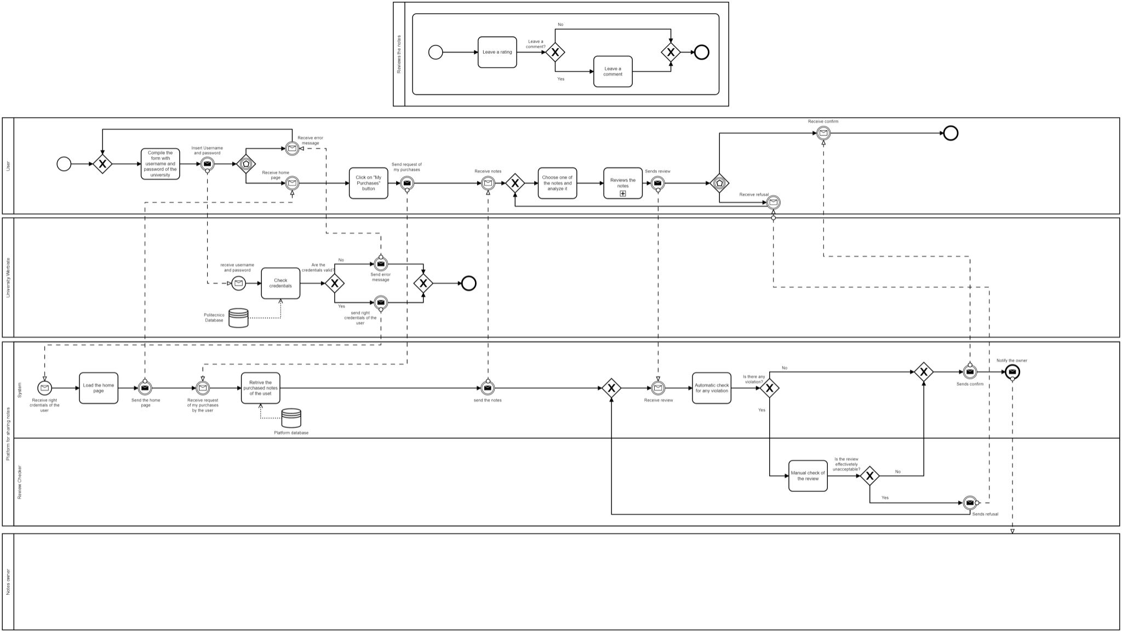

**BPMN 2 - Customer leaves a review**

In the second case we described the process in which the users leave a review.

In this process the actors are: the "user", responsible of leaving a review after the purchase of some notes, the "platform", which is furtherly splitted into two roles: the "system", that operates the automatic tasks of the process (for example he can report a review that contains unacceptable keyword ) and the "review checker", responsible for manually checking notes after the system reports a violation, such as the usage of an inappropriate language.   
Finally there is the "owner of the notes" who gets notified every time a review to some notes he uploaded is left.   
We decided to model it as a black-box because the actions that the owner of notes regard as a different process with respect to the one we are describing. Besides, we decided to model the process of the creation of feedback (mandatory rating + optional comment) as a subprocess that is visible above the 4 pools.

We decided to choose this activity due to its cruciality in our platform and because it directly affects the quality of the system that is an very important aspect for our platform that makes reliability one of its greatest strengths.

In this case we assumed that the user has already done the login task and he has already received the homepage. Both this aspect can be seen in the previous diagram.

# 

# 

# 8) User interaction and user interfaces

**1.IFML**

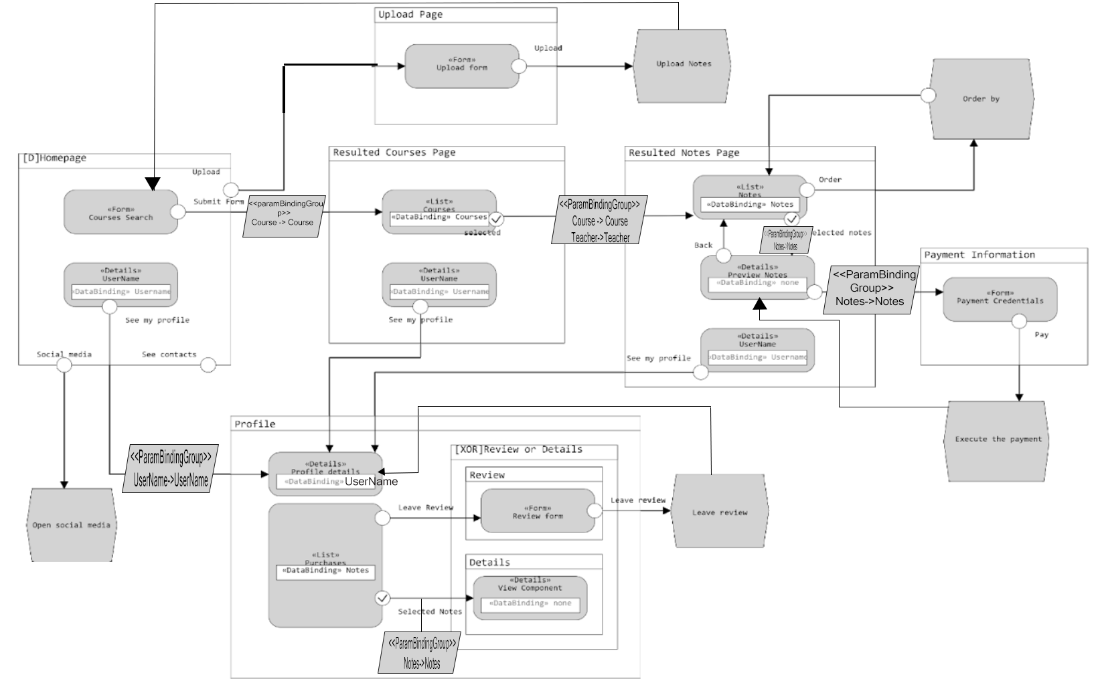

We decided to represent a broader interaction between the user and the system which starts from the homepage of the website of the platform for note sharing.

Once the user has accessed the homepage he can compile the form to search the desired notes if he comes with the goal to download something or he can press the upload button to start the procedure to load one of his notes on the website.

In the selected scenario, we concentrate more accurately on the flow of the interfaces for the download operation, so after the user has filled the form to search notes, he collects the list of suitable courses based on the research. At this point he selects the interested course and so in a new page he can see the uploaded notes for that course. Successively, the user can evaluate the notes (for example by rating or by number of downloads) and pick one. In a new web page he can see more details about the selected notes and if he wants he can click a button to see the preview of it. At the end, if the user is convinced by the preview of the notes he can start the procedure to purchase it.  
It is also important to mention that in each web page there is the possibility to access the area reserved to the user where it is possible to see the details about the user and the list of the previously purchased notes. From this list, the user can decide to see more details about a specific purchase or to leave a review about it if he didn’t precedently.

**2.Wireframes**

To get a more tangible grasp of the site's functionality we depicted two schematic pages of the notes sharing platform.

**2.1 Homepage**

This first screen is a visual guide that represents the skeletal framework of our homepage. We’ve chosen it with the purpose of showing how the user can start the procedures of the two main functionalities of our platform: searching and uploading notes.

In this page we have five main components.

First, the “Search notes” consists of a form in which the user can insert some parameters that he can exploit to do the research, once he submits, a new page with the results of the research is provided.

Second, the “Upload” button with which he can upload new notes.

Third, the “photo and username” represents the redirect to the user's personal page in which all his personal data are shown. Besides, in this page there’s the section dedicated to the reviews left to the purchased notes of such users.

Fourth, the “contact us” redirects the user to the page of the contacts of the platform owners.

Fifth, the “social media” buttons, which open the respective profile of the platform on those social media.

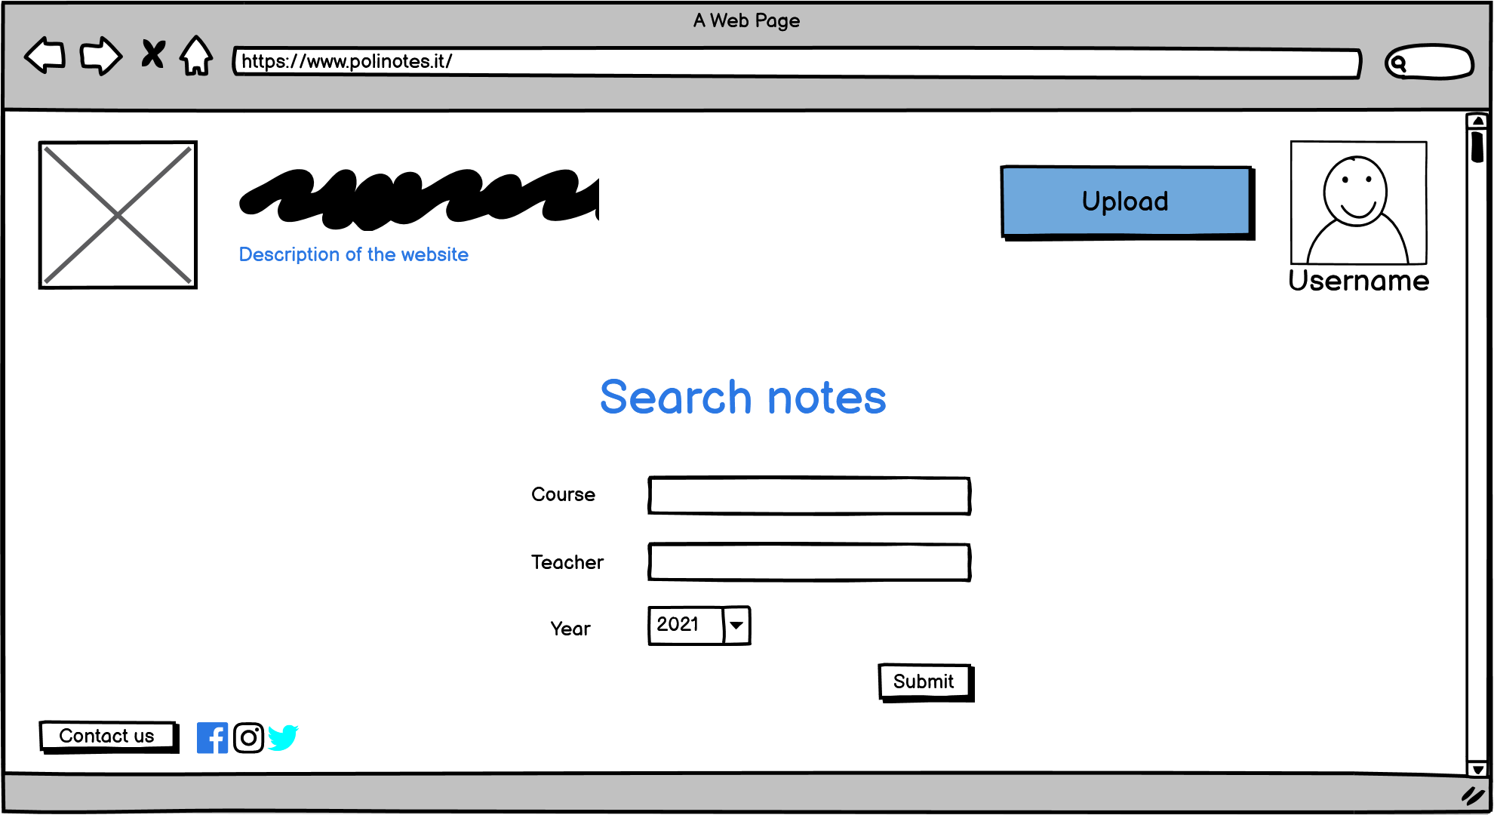

**2.2 Search notes**

The second wireframe represents the webpage in which the user can see the lists of the notes belonging to the course specified in the research form on the homepage. More precisely, the list contains for each note a thumbnail and few information about the note including the price. The notes are ordered by default according to the higher ratings but the user can choose to display them based on other criterias. If the user is interested in a specific note, he can click the “Preview” button to see the preview of it.

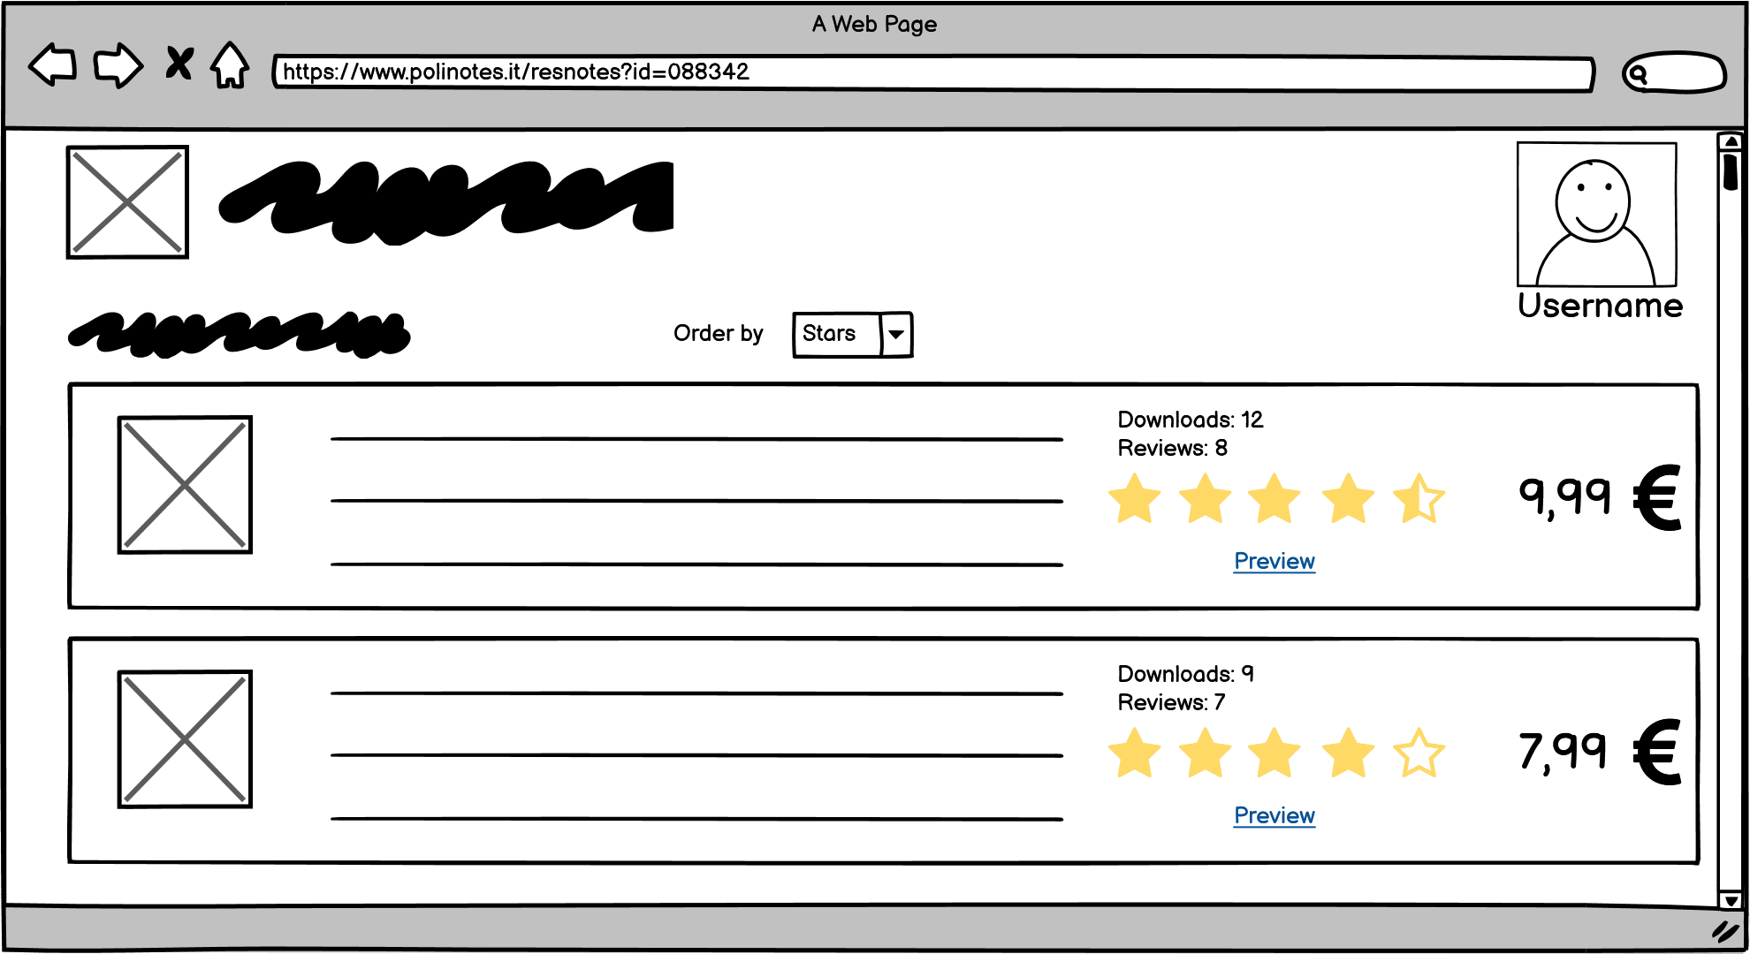

**3. Mockup**

The following mockups are inspired by the wireframes shown in the previous pages.

**3.1 Homepage**

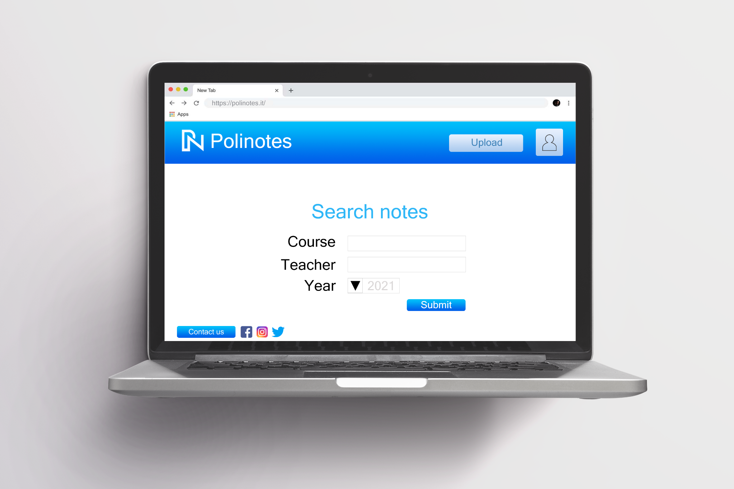

**3.2 Search notes**

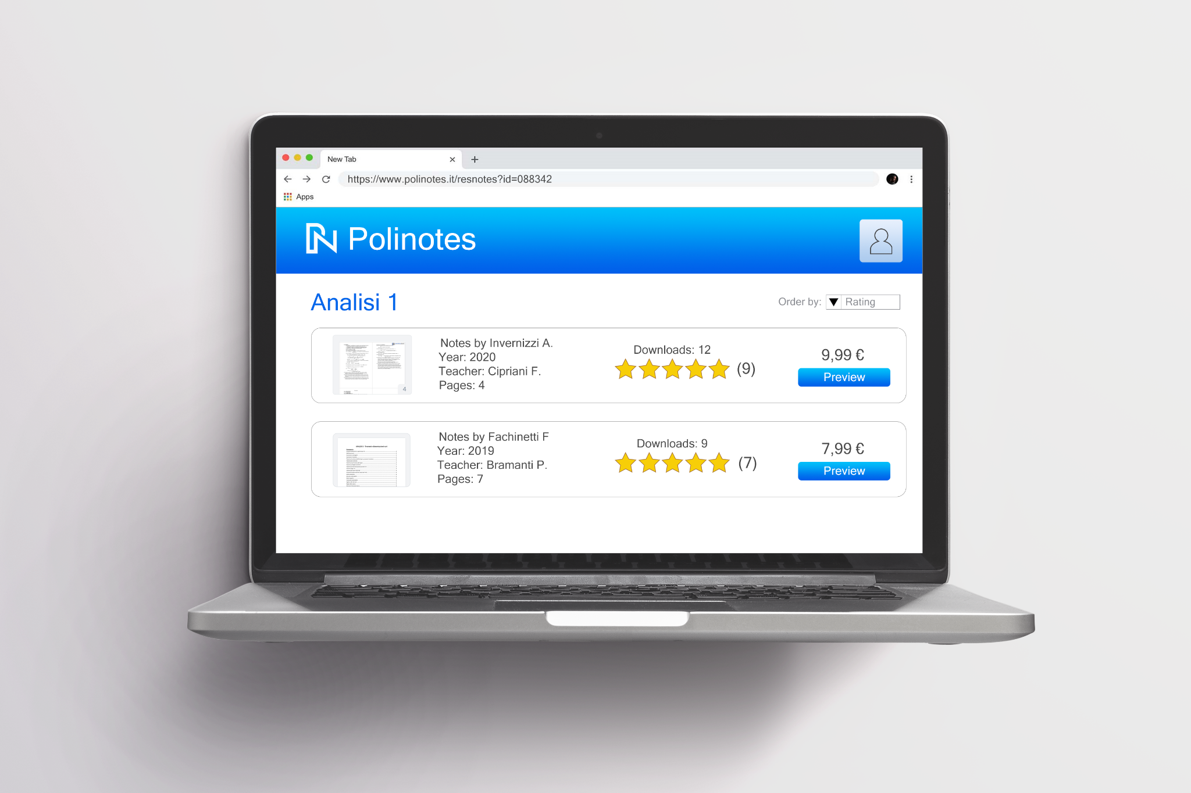

# 

# 9) Information System & Enterprise Architecture

**1. Data-driven decision**

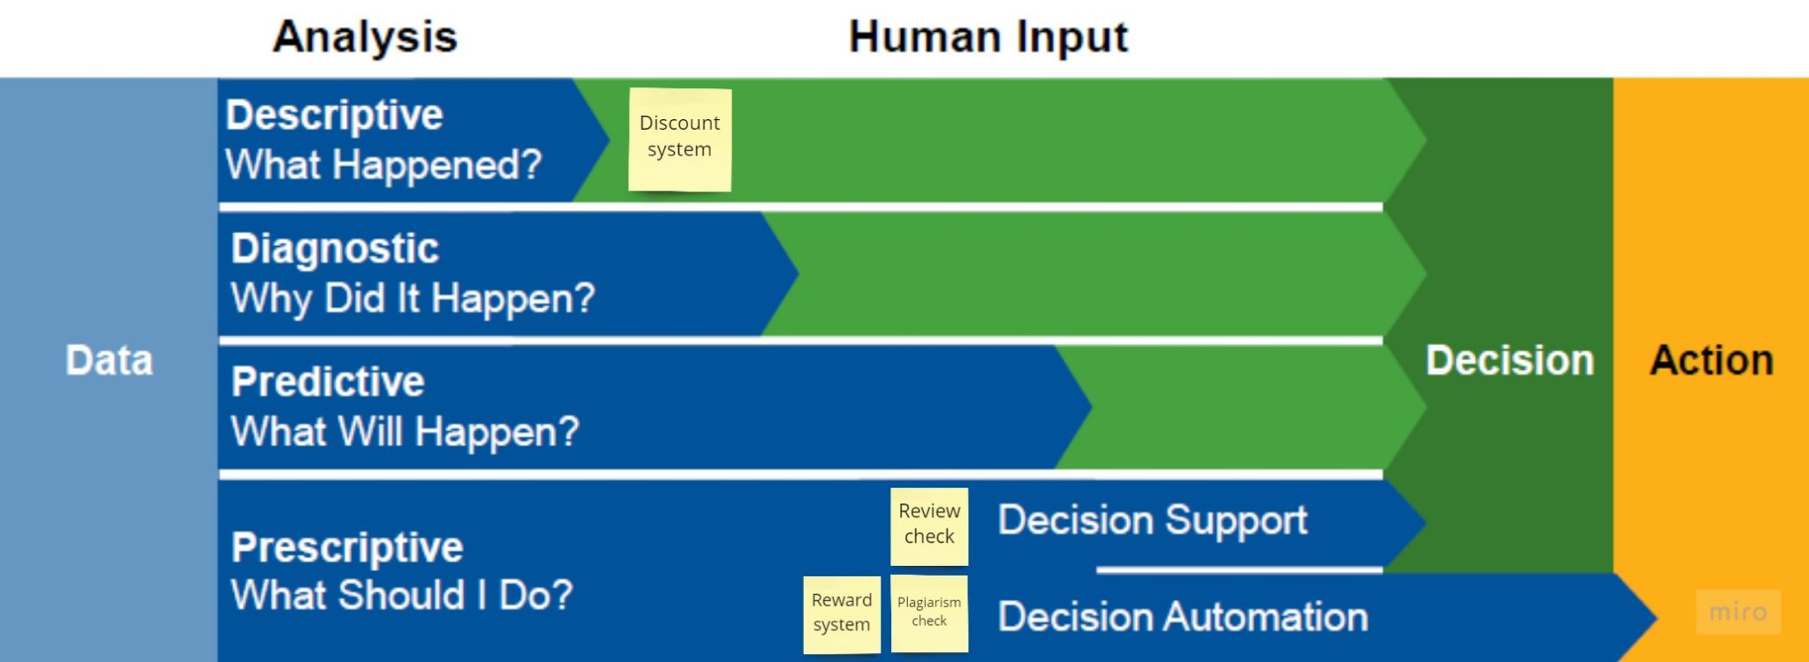

Regarding the data-driven decision by Gartner, we selected four aspects of our solution that are really important to improve the experience of uploading or downloading notes that are the core of our solution.

**1.1 Review Check : Prescriptive analytics → Decision support**

One of the core aspects of the platform of sharing notes consists of the possibility to leave ratings on the purchased notes. They are very helpful for the other users because they allow to mark dependable and good-quality notes. Since we want to keep the reviews as staid, the platform contains a system to check the reviews left by the users. This system has an automated part in which there is a control based on some keywords that are previously marked as “bad words”. Then if there is a match between these keywords and a word in the review left by the users, the review is sent to an employee that has the final decision about eliminating or not the review. This is done because sometimes the keyword brought in a certain context could assume a meaning that can be accepted. We placed this aspect of Review Check as Prescriptive - Decision Support because the automated system provides support to the final decision of eliminating or not the review that is taken from an employee of the platform (and so it is not automatic).

**1.2 Check of plagiarism**

Every time a new document is uploaded, an automatic system checks whether the document has been already uploaded in the database by another user or it’s just a copy with minor changes. Since this control is made in an automatic way, this aspect of our system is considered prescriptive - decision automation.

**1.3 Discount System**

The platform of sharing notes wants to enable well-done notes that are new to be visible, and so appreciated, by the user to improve the general quality of the service. To do so, the system contains a tool that for each course analyzes the performance (in terms of number of downloads the rating) of the uploaded notes. Then, these results are used by the managers that can decide the parameters of the notes (still in terms of number of downloads and ratings) that are suitable for a discount and so increase their visibility. We placed this aspect as descriptive because there is an analysis of the notes while the final decisions and so the actions of the discounts are taken by employees of the company.

**1.4 Reward system**

In order to give the students the guarantee of purchasing notes of good quality, the users who received a good average rating (4 stars out of 5) after having uploaded at least ten uploads, will receive the label “trusted” next to his username and his uploaded notes. Since this decision is made automatically, it is considered prescriptive - decision automation.

**2. Information System Architecture and Data Flow**

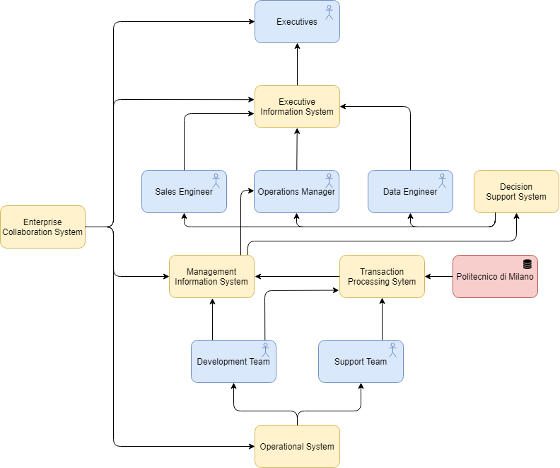

Since we consider our organization as a startup, the information system architecture will be quite simple. There are two teams who will exploit the operational system: the developer team and the support team, which will help in tasks like review checking and other operational tasks. Politecnico di Milano will provide the data to let the students access the platform using their credentials from the database of the university.

The Management Information System, Transaction Processing System and Decision Support system are needed to manage the system and will provide the data to:

* Sales engineer, who has the task to monitor the state of the application and to take actions in order to improve it as amending the recommender system of the notes for the platform.
* Data engineer, which has the crucial task of designing, building, installing, testing and maintaining data management systems, managing the flow from the sources to the Data Management platforms. It also monitors the flow of data in the system.
* Operations manager, who supervises and optimizes all business processes

Finally, all the information flow will arrive at the executives, who will have to make the main decisions to manage the high-level strategy of the project. An Enterprise Collaboration System will be exploited to support operations and communication between all the actors of the project.

**3. Enterprise Architecture**

**3.1 Network & Infrastructure**

The platform for notes sharing is deployed as a web app on a three-tier architecture, this architectural style directly influences a number of QoS: promotes a high decoupling of the system, increasing the reusability, scalability and flexibility.

* The Client-tier provides an interface to the various users.
* The Server-tier elaborates requests and provides the business logic. It also maintains a single persistent connection to the Database, which is a less expensive and more secure solution.
* The Data Source-tier contains both the DBMS and the Database for the Application data, we rely on a third party company which provides the service for hosting the servers.

The communication protocol used to exchange messages is HTTPS, which means we’re using http over ssl. SSL is used to guarantee the security and the reliability of the connection. This is also endorsed by the crucial role that data plays in the system. Regarding the format in which the data are transmitted, JSON is used for its performances, since it is designed specifically for data interchange.

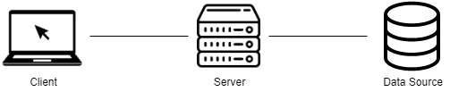

**3.2 Information & Data**

The solution relies on 2 different databases:

* Since the login is realized with the authentication mechanisms of the Politecnico di Milano, the platform indirectly relies on the database of the Politecnico that contains the credentials of each student.
* A second database is used to store all the other types of data present in the platform such as the uploaded notes, the reviews and so on. Therefore, the system relies on a third party provider: Oracle Database, that is optimized also to store large quantities of files.

**3.3 Application & Systems**

The solution is based on:

* A Web Application used for sharing notes, which will be the main focus.
* A plagiarism detector tool will be exploited in order to check if any uploaded notes have been stolen from another user of the platform.
* A tool that is able to detect the potential nasty reviews, checking if the review contains some words marked as bad.
* A recommender system to suggest the notes in which the user is potentially interested based on his previous purchases.

**3.4 Business**

In order to support the decision on the strategies to choose, the business level consists of different tools used to analyze the performances of the platform. In particular, for our solution it is very crucial to have a report about the number of downloads and ratings of each note. Besides, having some data about the behavior of each user of the application allows the managers to make thoughtful choices regarding their reliability and how to improve the system, maybe exploiting indexes such as the time after which an user leaves a review to a note. It is also useful to evaluate the number of visits to the website and in which part of the year are the peaks of traffic, in this way can be decided to take selling strategies.

The managers of the company can indeed use a discount system that allows them to apply a discount to notes specifying the parameters (in terms of original price, number of downloads and ratings) that the notes should have to benefit from the discount.

**3.5 Strategy**

The solution is addressed to all the students that for different reasons are unable to follow the lesson in presence. So, the solution provides a system for buying and selling notes that enable both the actors of the platform (who buys and who sells) to continue to use the system respectively to make more money or to obtain additional and well-done material for the preparation of an exam. This platform is developed as a webapp that is easily accessible by all the students and that being integrated with the authentication of the university allows easy access to all the students of the Politecnico. Obviously, being a webapp the notes are shared in the form of a scanned file; this is not a problematic aspect because nowadays most students take notes directly on technological devices and in any case there are several tools that allow an easy scan of the paper.  
The short-mid term of the startup is to make the platform of sharing notes a recognized and appreciated instrument by the students of the Politecnico di Milano.

The long term objective is instead exploiting the good reputation acquired from the collaboration with Politecnico di Milano to expand the business in other italian universities.

**4. Zachman Framework**

We tailored the Zachman Framework to our specific solution for sharing notes, this helped us in defining the roadmap to follow. In each cell we put a general description on what our organization should insert.

|  |  |  |  |  |  |  |
| --- | --- | --- | --- | --- | --- | --- |
|  | **What**  **Data** | **How**  **Function** | **Where**  **Network** | **Who**  **People** | **When**  **Time** | **Why**  **Motivation** |
| **Scope context** | List of crucial aspects and data related to the problem of sharing notes:   * data of the users * data from Politecnico | List of high-level processes needed for the solution and the internal organization of the startup | List of the technological platforms in which the solution will operate | List of the stakeholders of the company (including the members of the startup) and the universities for which the solution is tailored | List of the relevant events related to the university, like the semester, academic year and exam sessions | List of the business objectives and goals to reach, such as providing reliable and proven material, and strategies to adopt such as those previously defined in the goal poster |
| **Business Concepts** | Definition of the relationships between the entities involved  (ER Diagram with user, notes, course, faculty, teacher, purchase and review) | Definition and formalization of the processes needed to share notes  (BPMN models to organize the process of purchase of notes and the review of notes) | Logistic network, specific location of the startup in Milan | Definition of the workflow model, identifying the roles of the each member of the startup by defining each actor and the hierarchical organization in the information flow | Definition of the project timeline with respect to the major business events (PERT chart of the development of the webapp) | Definition of the Business Plan of the startup and the internal policies and guidelines to follow |
| **System Logic** | Description of the logical data model of the data elements and their relationships in the system (further detailed ER diagram) | Description of the architecture of the application for the processes needed to share notes by using the data flow diagram | Description of component diagram of the webapp (infrastructures, servers, devices, networking...) | Description of the human interface architecture through role relationship diagram to describe the responsibilities, and through wireframes and mockups to describe the relationship with the users | Description of the schedule of the activities focusing on their timing (download, upload, leave review, data flow...) through tools as Gantt Chart and block diagrams | Description of the business rules model of our platform (internal rules, such as policies and guidelines, and external rules imposed by Politecnico di Milano, about the usage of the data) |
| **Technology Physics** | Physical data model of the data elements used by the platform for sharing notes that supports a big amount of data and highlights the relationships between data entities (PDF files, reviews, ratings, user profiles, subjects) | Concrete design of the system:   * webapp: 3 tier architecture; * Databases: both MySQL (to store user’s data) and NoSQL (graph and column databases to optimize the research); * Protocolos: usage of secure protocols and optimized data transfer format ( JSON over HTTPS) | Description of the technology architecture used in the webapp through deployment diagram: network, server, computers, devices, third party services | Usage of internal organizational tools for the assignment of the tasks to each member of the startup. Regarding the relationship with the user, presentation of  the webapp through mockups and screens to enhance the exchange of feedbacks | Control flow diagram to check the progress of the activities and whether it’s proceeding as planned | Application of the business rules (internal)l and external designed for the startup |
| **Component assemblies** | Specification of the database schema in which the data used in the webapp are stored | Development of the code of the entire platform | Development of the Network architecture used to connect the components of the platform | Specification of the security mechanisms adopted into the platform (privacy of users, copyright of the uploaded notes…) | Description of the behavior of different objects within a time scale | Definition of rules to follow to structure the components |
| **Operations classes** | Data instantiation: all the previous provided data plus the data acquired by the usage of the application by users | Function instantiation:   * authentication; * download and upload; * review of downloaded notes | Network instantiation: access to the platform of note sharing can be done through the webapp | Organization instantiation of the relationship between the members of the startup and the users of the platform | Schedule instantiation of the operations to be performed, running schedule. | Strategy instantiation adapted to the trends of downloads |

# 

# 10) CRM & Recommender System

1. **Information System and Data Flow**

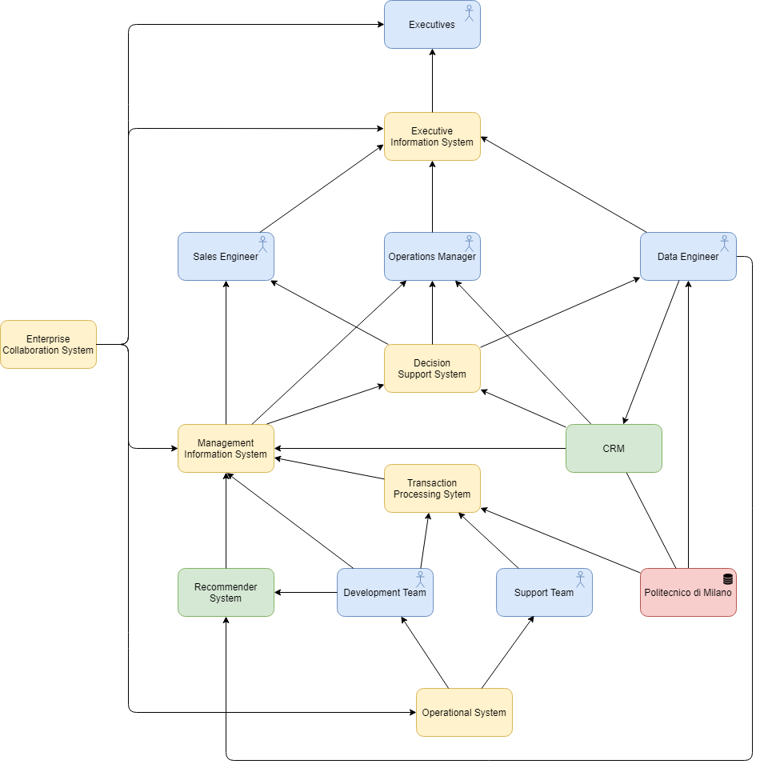

***Recommender System***

The recommender System is a very important tool for our organization. Regarding its position in the information system architecture, it is directly connected to the development team that has the task of the deployment and the maintenance of it. It is also connected directly to the Data Engineer because the Data Engineer is responsible for the selection and the transformation of the right data to feed into the RS. Then, the RS is connected to the Sales Engineer passing through the Management Information System because the Sales Engineer tries to understand the general quality of the entire Recommender System analyzing the statistics of the downloads suggested by the system.

***CRM***

Into the organization, the CRM is directly integrated into the Management Information System and Decision Support System modules in order to support the process of business decision-making performed mainly by the Sales Engineer and the Business Manager. CRM is also directly connected to the Data Engineer because it is responsible to monitor which data and the quality of the data to insert into the Customer Relationship Management.

1. **CRM - CUSTOMER RELATIONSHIP MANAGEMENT**

**2.1 How do we plan to develop the CRM solution?**

In order to build a better relation with our current and future customers we have decided to split the main steps of our strategy.

Our strategy for customer relationship consist in:

* **Customer selection:**We firstly defined our audience. Since the platform provides a service of note sharing which should help in the preparation of the university exam, we have decided to focus on the University students, who will be our customers. We want to give the students the opportunity to save time while at the same time to gain money exploiting their fatigue spent in adjusting their notes. More precisely, we focused on the students of Politecnico di Milano that may have some problems in following the lectures due to overlapping courses or different time zones for example, or simply those who want to exploit our solution to earn some extra money enhancing their work as students.
* **Customer acquisition:**To reach our customers we focused on different channels. First, our solution will be advertised on the PoliMi website, this will guarantee the adequate reliable reputation that a platform of this type requires, since the reliability of the sources is a crucial aspect. Then we will push it also through the social media channels, since they are very effective to reach as many as possible students. Finally, we will also use the polimi email address to notify all the students about this solution.
* **Customer retention:**

To keep the current customers as long as possible on our platform we have thought about some “actions” to take; they are mainly focused on improving the quality of the material provided by the platform, which is the most crucial aspect for the success of this solution. In particular we have anticipated a system of discount which aims to push the notes with good ratings but few downloads, this should also help in giving visibility to well done material that is uploaded afterwards.  
Furthermore, there’s the system of reviews. Since they are left by the users who bought a particular note, it helps in having a crowd-source evaluation of the notes.

* **Customer extension:**

To increase the loyalty toward our platform we have anticipated a solution that allows us to identify the most reliable students who upload notes. This is obtained thanks to the “trusted” label that is placed next to the name of the user. This label can be obtained only after having uploaded at least 10 notes and having received an overall average rating of 4 stars out of 5. By identifying the most reliable user we aim to obtain two things: an increase of the loyalty toward the platform by the “trusted” user and an increase of trust towards the platform by the users who can be sure to acquire material from reliable sources.

Another way to increase the loyalty of the customer towards the application is a sort of virtual loyalty card that gives access to a series of discounts as reward for having purchased a certain amount of notes uploaded in the platform.

**2.2 What kind of relationship?**

The goal of the organization is keeping as much as possible the customer onboard with the solution. In this way indeed we can make sure that new materials will be always inserted into the application and this is very important because we know that the programs of the courses can change over the years. Also, if customers continue to use the solution, a lot of notes will be purchased making students willing to upload more material to gain more extra money; this aspect helps in keeping the quality of the materials in the application high, which is a crucial aspect of the solution.

**2.3 Technical description of the solution adopted**

**What data do we collect?**

Into the CRM, we are going to collect all the data regarding the unìversitary profile of the students.

More specifically:

* Bachelor/Master Degree;
* Faculty;
* Matriculation Year;
* Birth Date;
* Email address.

Moreover, we analyze their behaviour by counting:

* Number of downloaded notes;
* Number of uploaded notes;
* Number of reviews left;
* Average rating.

**What do we trace with the interaction with the customer?**

Regarding the customer, we are going to trace the number of downloads and uploads performed into the platform. We are also going to store the average rating, the percentage of reviews left by the user after a purchase and the average time passed between the purchase and the leaving of the review. All of this information is useful to understand the general behavior of the single user but also to the entire pool of users in order to deploy some discount plans.

**What view do we give to the customer and to the employee?**

In order to give to the customer a better experience, the website is going to show him:

* Number of downloads and reviews for every notes;
* The most relevant review left for every notes;
* The average rating of every notes;
* The “label” of trusted next to the users who deserved it;
* Suggested notes based on the course followed;
* Suggested courses based on the area of study;
* Discounts for the deserved notes;

Furthermore, to support our employees, we are giving him a view composed by:

* Number of uploaded notes per course;
* Number of uploaded notes per user;
* Number of ratings left for every user;
* Ratio between ratings left and number of purchases per notes;
* Ratio between good ratings (over or equal to 3 stars out of 5) and bad ratings per notes;
* Ratio between number of reviews and number of purchases per user;
* Average rating received per user;
* Average time after which a user rates some purchased notes;

1. **Recommender System**

**3.1 What do we plan to recommend?**

Being our solution, a platform of sharing notes, the recommender system will suggest the best-rated notes of courses that could interest users based on their previous interactions that can be purchased or simply researched.

**3.2 How do we plan to recommend?**

The recommendation will appear in the home page of the website when the customer access the website or it can sent as an email if the customer doesn’t return on the platform for a few days (this can be also a way to remind the user about the existence of the website and so trying to increase its retention with the solution).

**3.3 Implementation**

|  |  |  |  |  |
| --- | --- | --- | --- | --- |
|  | Mathematical Analysis 1 | Mathematical Analysis 2 | Analytical mechanics | Linear algebra |
| Customer 1 | x | x |  | x |
| Customer 2 |  | x | x | x |
| Customer 3 | x | x |  |  |

**What kind of implementation are we going to use?**

The most suitable type of Recommender System for this purpose is an Association Rules one, which is a collaborative (social) one that works at the item level, made for the various courses present in the platform.   
It is a probabilistic approach in which we estimate the probability that something will happen if something else happened in the past. In our solution, we estimate the probability that if a certain user has looked at or purchased a certain note regarding a certain course, it’s likely that he/she will need notes of another certain course. We chose to implement this type of Recommender System because in our context the individual tastes of a single user are not relevant since the specific courses for which he is interested don’t depend on him but from his faculty. For this reason we can also infer that the “preferences” of the users will not change rapidly because they are linked to the program of courses of the faculty that generally remains the same with very few variations.

Past purchases are transformed into relationships of common purchases.

For example, in the table above, since customer 3 has purchased notes of Mathematical Analysis 1 and Mathematical Analysis 2 like customer 1 and since both of them follow the same faculty, the system will suggest to the former to download the notes of Linear Algebra.

**What data are we going to exploit in the recommender system?**

We are going to exploit the data received in the CRM, like the faculty of the user, to find out which courses he should follow in order to suggest to him the courses related to them.

This data can represent the starting point of the rules that can be then refined by feeding into the algorithm sequences of purchases or researches effectively made by the users.

Moreover, we will check what are the most purchased notes by his classmates and which ones have the best average rating.

# 11) Data Layer

**What data are we going to store in our database?**

The data stored in our database will have two different sources.

The former is the database of Politecnico di Milano, from which we will receive data associated with personal information of the users such as:

* name;
* surname;
* gender;
* e-mail;
* course;

by asking the consensus of the student.

This data, with the list of the courses of the University, will be copied in our database (to be exploited in the CRM) while the credentials associated with the login (“codice persona” and password) will stay in the original database.

Other data will be inserted directly by the user during the purchase of the notes, such as billing data (billing address, city, postcode, country, state, card number, expiration date, cvc), and also during the upload of notes:

* PDF file;
* title of note;
* academic year;
* professor;
* course;
* price;
* description;

About the reviews, when a new one is left, the information required are the rating (a number of stars between one and five) and a text description.

Finally we will also save the data about the purchases, like the notes that have been purchased, the purchase data, the name and the surname of the buyer and the owner of the notes.

**How big is the database? In which way it will evolve? How much is it growing?**

The database should be capacious enough to store at least all the students of the Politecnico with the possibility to scale up.

Besides, since we want to provide a scalable platform, we have designed our solution planning to expand our platform to other universities, so the database will be projected to include data about the other university of the students and the courses that it offers. To do so we use a NoSQL solution which allows us to extend our schema to further type of data and new fields.

**Volume estimation:**

The estimations of the interactions with the platform have been done by observing the statistics of other platform that provide notes for free and then adapting them to our case in which the number of users is limited (because the number of users is at most the number of students of Politecnico di Milano) and especially considering that in our platform the notes are paid and so we expect in general a minor number of downloads.   
We have assumed that the number of uploads per day will be on average half of the number of downloads.

It is also important to consider that our platform, being a further tool that students have to better prepare for an exam, is expected to have peaks in months characterized by the exam session , so January-February and June-July.

Summing up with some numbers:

* 50k students (and so potential users) ;
* 5k visits (in average) to the platform per day;
* 1k downloads (in average) from the platform per day;
* 0,5k uploads (in average) per day;

Since in our system we need to store also the history of uploads, purchases (downloads) and the visits (that are the data used into the recommender system), we need for the first year of the deployment of our application a database that is able to store at least:  
(50k + 5k + 1k + 0,5k)*365 = 20.622.500 tuples.

This is only for the first year, since we expect that:

* Number of students enrolled in Politecnico grows yearly (5k every year);
* The number of downloads and uploads will grow each year because the students become more comfortable with the platform and the platform itself started to be recognized as a useful tool to better prepare for an exam.
* If more people download notes then there will be more reviews left so the number of ratings and reviews increases.

**Conceptual data Model (ER)**

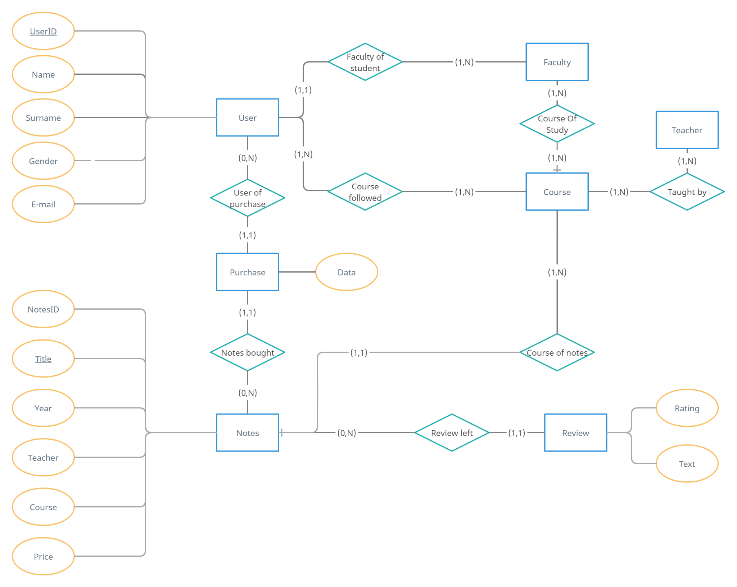

**What data model family are we going to use?**

Based on the type of information that we want to store into our platform we have decided to adopt 2 different families of NoSQL Databases:

* **Graph Based Database:** to store different types of relationships that in our context are very important to execute the main functionalities of the platform. In particular, we’ve used the Neo4J Graph Platform. These relationships links nodes that represent:
  + User;
  + Note;
  + Course;

The type of relationships are:

* “Upload” between User and Note;
* “Download” between User and Note;
* “Visit” between User and Course;
* “Belong” between Note and Course;
* “Reviews” between User and Note;
* “Reviewed” between Note and User.

The Image below gives a very concise overview of the data model, highlighting how the nodes are linked between them by the edges. 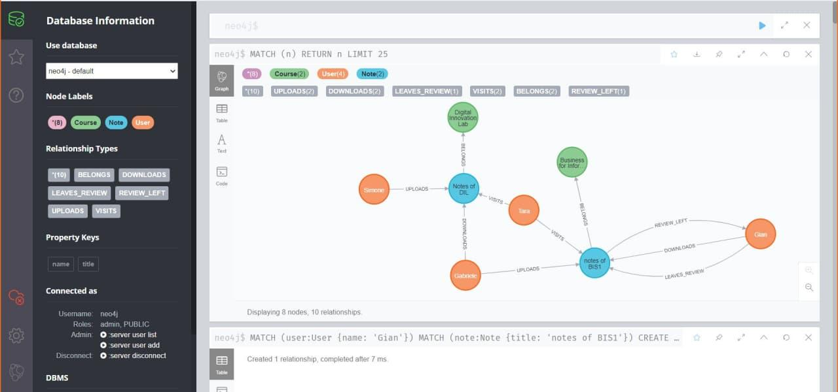

* **Column Based Database** to store the important information about all the objects that are the nodes in the Graph Based. We decided to adopt it because it is a useful and easy way to store within the same structure the additional information about users, notes, reviews and notes that have different attributes but that we can predict.

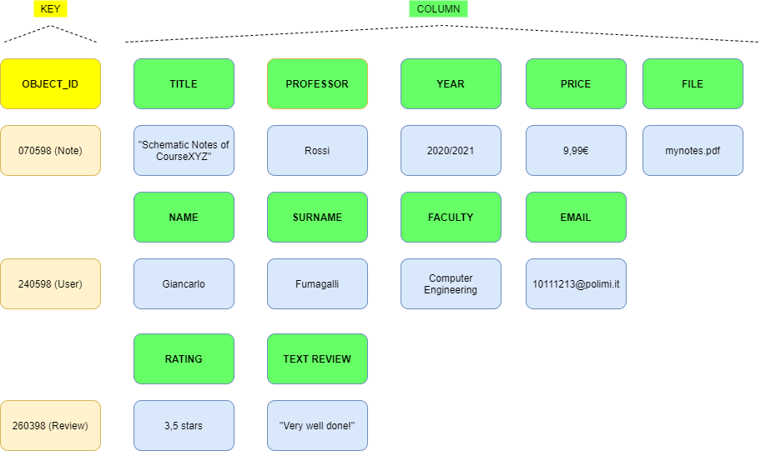

Based on logistic reasons, we have only inserted a few attributes for each type of row.

The idea is that the identifier of the objects that are the nodes in the Graph Based DB is the same row key of the Column-based one. In this way we can manage the relationships of the elements directly in the Graph based and then going to retrieve the additional information regarding the elements in the Column Based one.

It is important to mention the attribute “File”, it will contain the pdf file of the uploaded notes stored in a BLOB format. However, we know that column based database present a size limit of 10 MB for the stored file; being this size a reasonable limit for pdf files containing notes, the platform will impose this limit of the uploaded file.

**12) Implementation**

***Application Part***

Regarding the application part, we decided to implement a simplified version of the webapp that represents the prototype of our platform. In particular, we have implemented 2 main features of our platform that can be tested through the prototype:

* Search of notes (that implies the search of the courses);
* Rating and leaving a review of the notes purchased by a given user.

Starting the webapp, we can immediately see the homepage of the webapp. The homepage contains 3 most important elements:

* Form to search the courses that the user is interested in (it is the first phase in the procedure of searching notes)
* Upload button to start the procedure of uploading notes (the following part has not been implemented in this prototype)
* Personal page button to access the personal area of the user (so, we can understand that actually this page in the real system will be displayed only after the login that we decided to not represent because being integrated with the system of Politecnico, the login is not so significant for us to be implemented in a prototype).

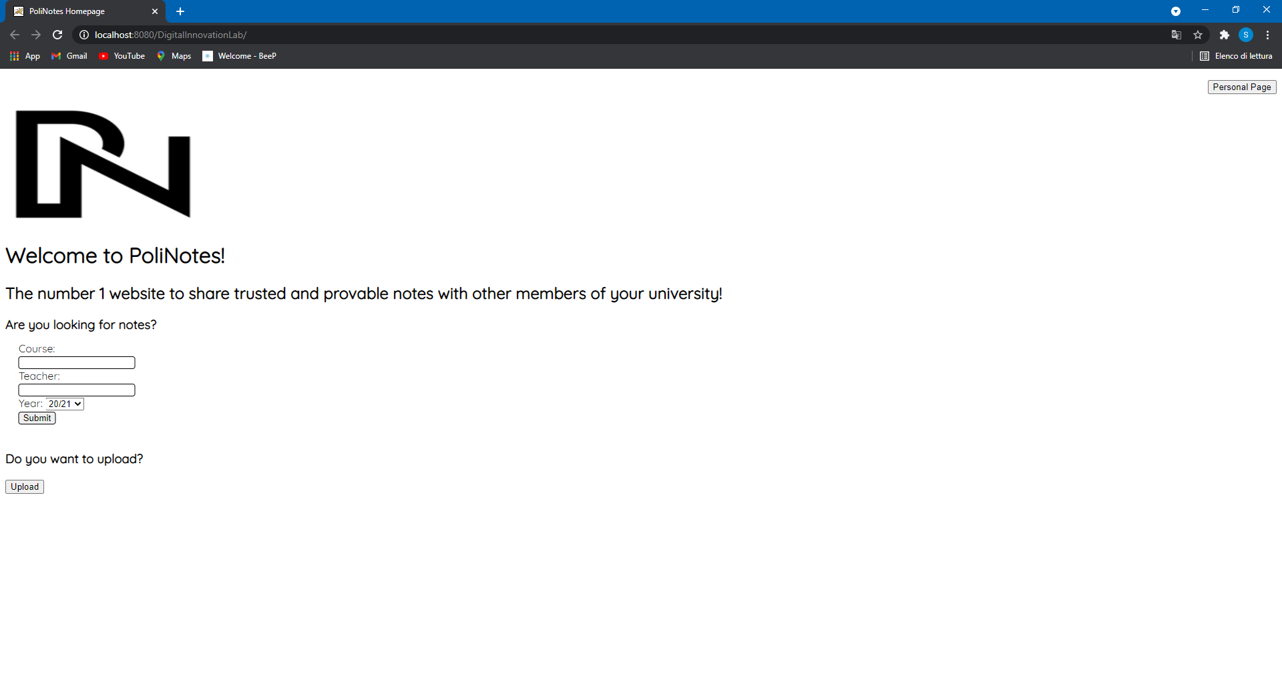

*Search Notes Procedure:*

Filling the form, we can start the search for the desired notes. It is important to mention that actually only the Course and Year field are mandatory to fill to start the procedure. Once, we have filled the form we can see the “Course Page”. We can say that the best way to implement the searching of courses could be developing a search engine, especially when the number of courses becomes very high in the system. However, for simplicity in the prototype we have used a simple SQL query with the % operator.

These are the results inserting “analisi” in the Course field and “19/20” as year.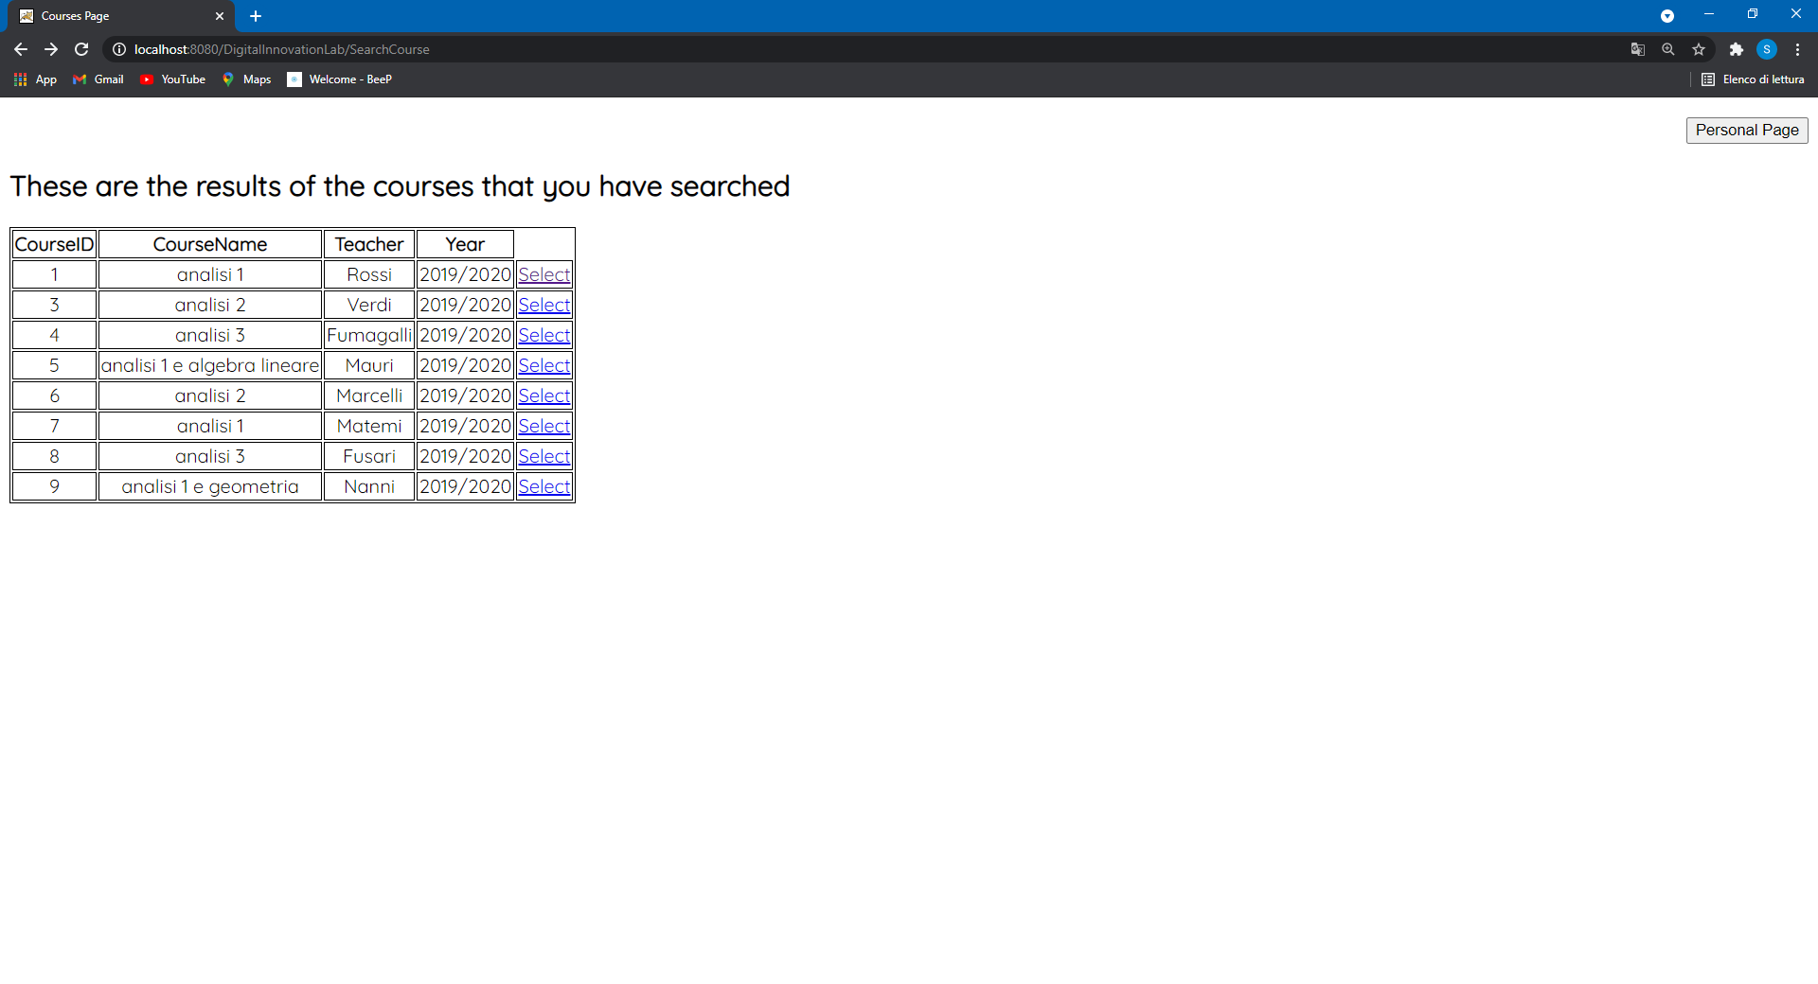

At this point, the user can select the course for which he wants to see the available notes that have been uploaded on the platform.   
For example, clicking on “Select” for the first result it will be displayed the “Notes Page”:

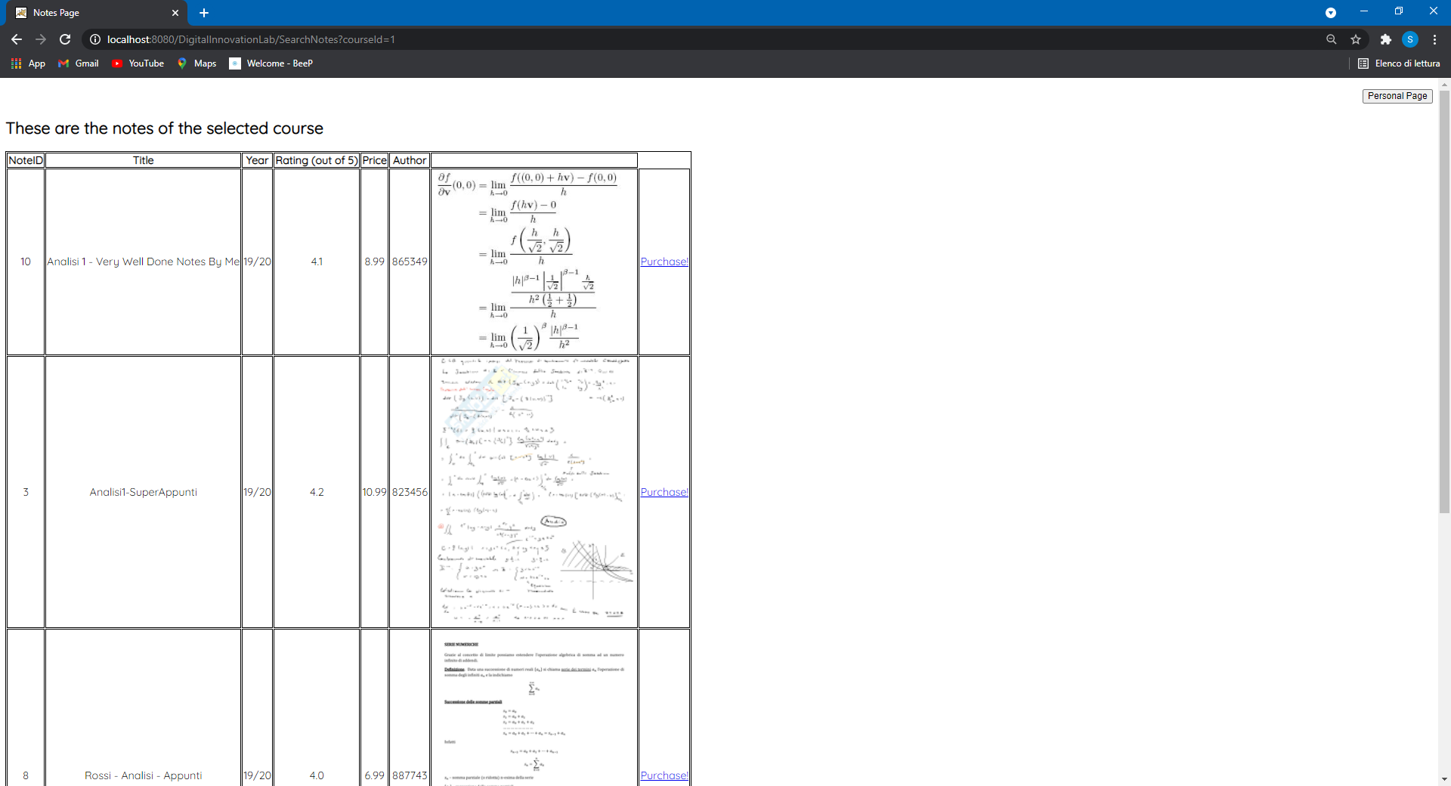

In this page the user can see all the information about the notes uploaded for that course as the title, the year, the uploader, the price, the average rating received and also a preview of the notes. At this point, if the user is convinced by one of these notes he can click on the “Purchase” link that will start the procedure for actually paying the notes after which the user will receive the pdf file of the notes (this procedure has not been implemented).

*Rating and leaving a review*

Starting from the homepage of webapp, if the user clicks on the “HomePage” button the personal page of the user will be displayed:

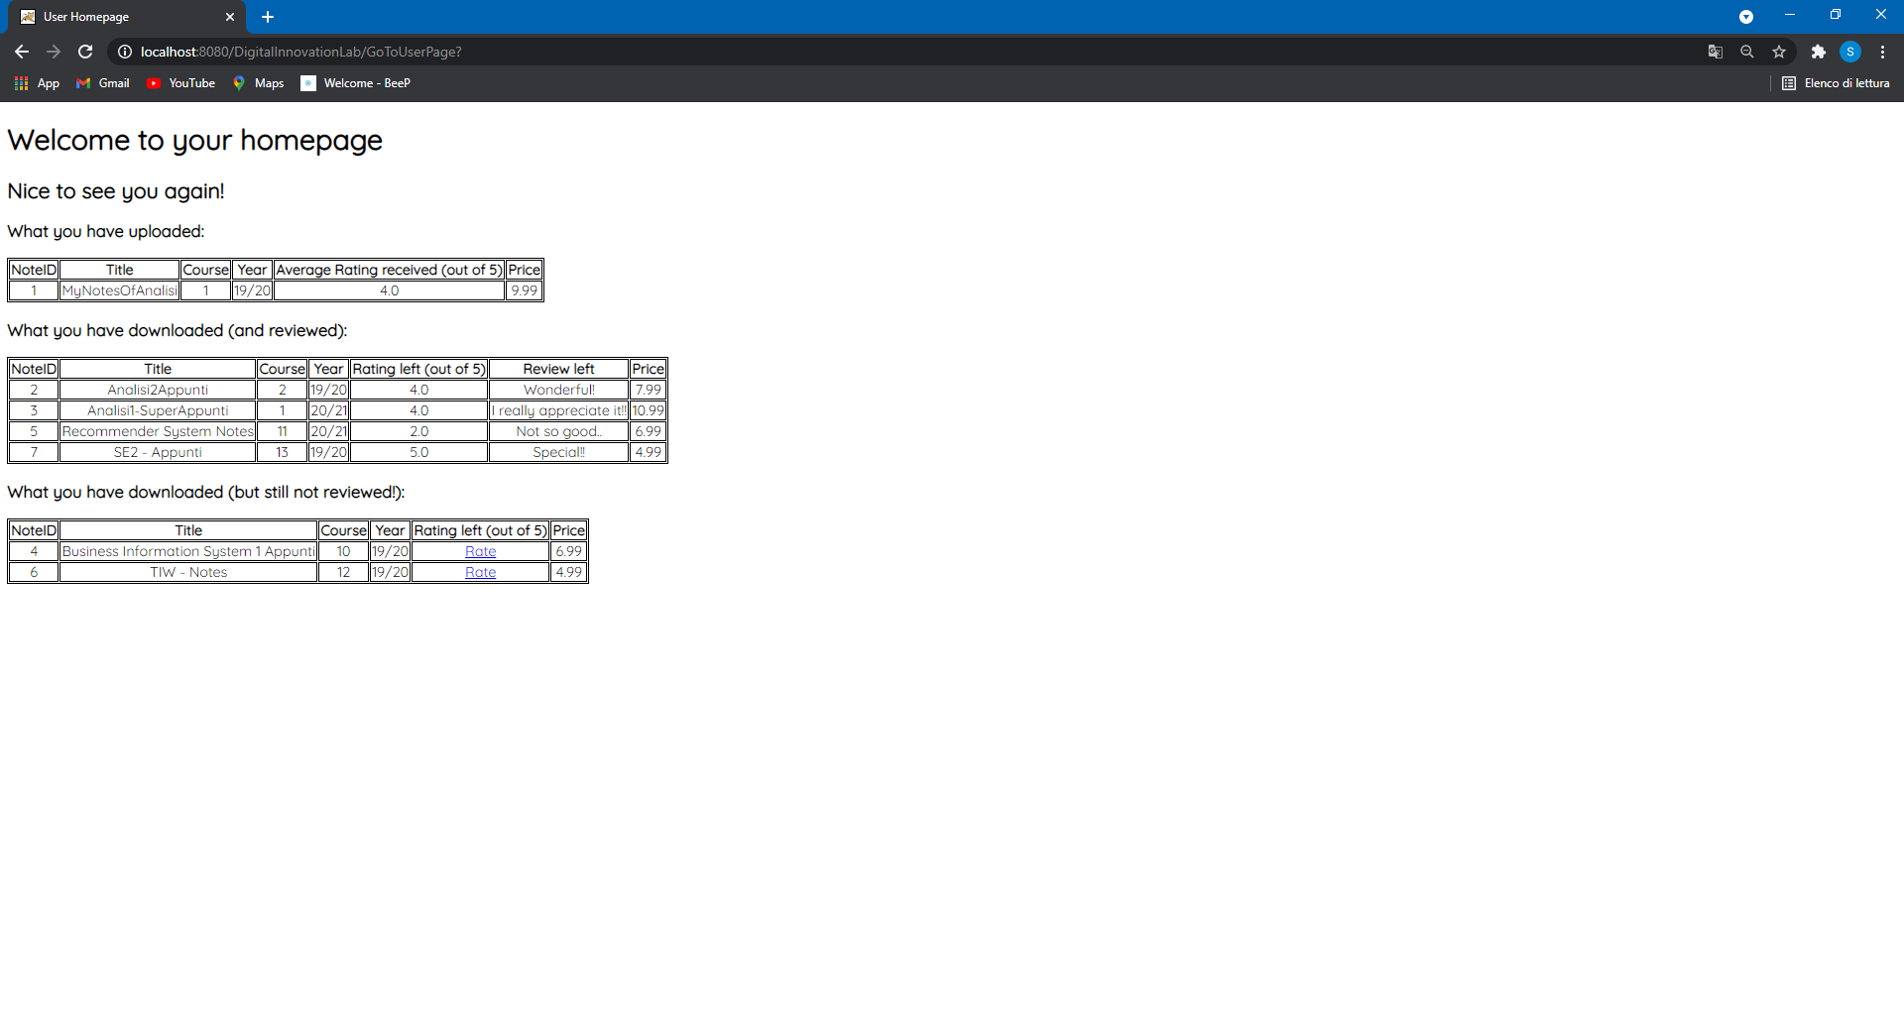

Since we have not implemented the login part, this personal page refers to a sample user.  
In this page, a given user can see the notes that he has previously uploaded together to the average rating received until that moment. Also, he can see the previous downloads that are divided in 2 groups: the download for which the user has already left a rating and a review or the downloads for which he didn’t. We decided to introduce this separation to remark how much is important for our application the fact the users leave a review.   
The unrated notes present the “Rate” link that brings the user to the “ReviewManagementPage”:

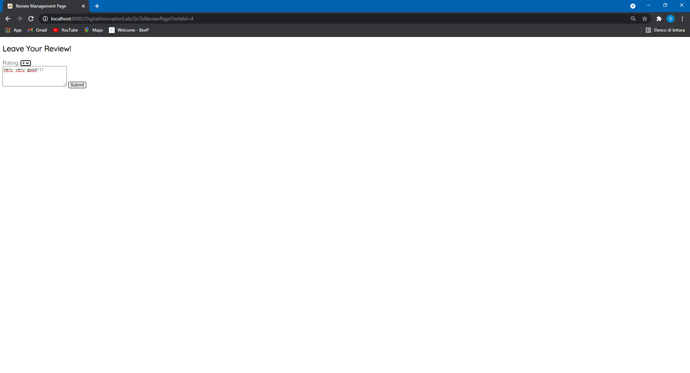

In this page, the user can select the rating to give to that note (from 1 to 5) and if he wants, he can also leave a review. Then, clicking on the submit button the user will return to his personal page that has been updated with the rating and the review that he has just left.

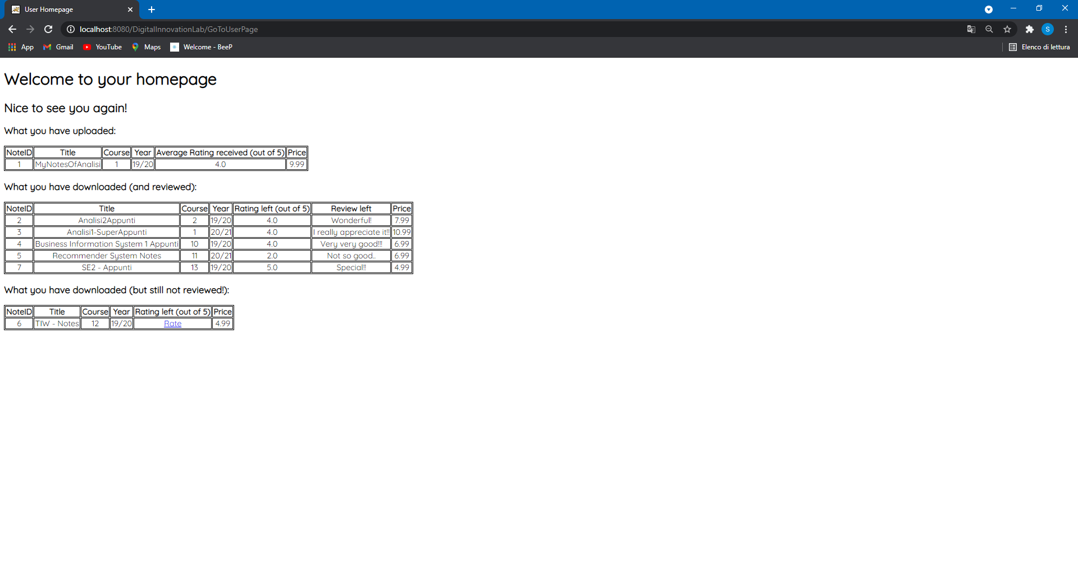

Regarding the technical part, the webapp has been developed as an HTML-Pure application. The backend has been implemented using JAVA Language; in particular we develop:

* Bean of the objects as JavaBean:
  + - CourseBean
    - NoteBean
    - UserBean
* Controllers: the servlet
  + - SearchNotes
    - SearchCourse
    - GoToReviewPage
    - GoToUserPage
    - LeaveReview
* Interaction with the database: DAOs
  + - CourseDAO
    - DownloadDAO
    - NoteDAO

The UI has been implemented with HTML Language and we also used the Thymeleaf template engine. The view is composed of 5 HTML Pages:

* homepage.html (the page that is displayed at the beginning)
* CoursePage.html
* NotesPage.html
* UserPage.html
* ReviewManagement.html

We also model the database that is used by the webapp using MySQL workbench. The connection with the database is handled using JDBC.

***Data Part***

We have adopted a type of NoSQL database for our application: the Graph Based Database, to store different types of relationships that, in our context, are very important to execute the main functionalities of the platform. In particular, we’ve used the Neo4J Graph Platform. This choice has been made based on different factors: the high performances it provides thanks to the native graph storage, the scalability and the ACID properties.

These relationships that link the nodes, represent:

* + User;
  + Note;
  + Course;

while, the type of relationships are:

* “Upload” between User and Note;
* “Download” between User and Note;
* “Visit” between User and Course;
* “Belong” between Note and Course;
* “Reviews” between User and Note;
* “Reviewed” between Note and User.

The Image below gives a very concise overview of the data model, highlighting how the nodes are linked between them by the edges.

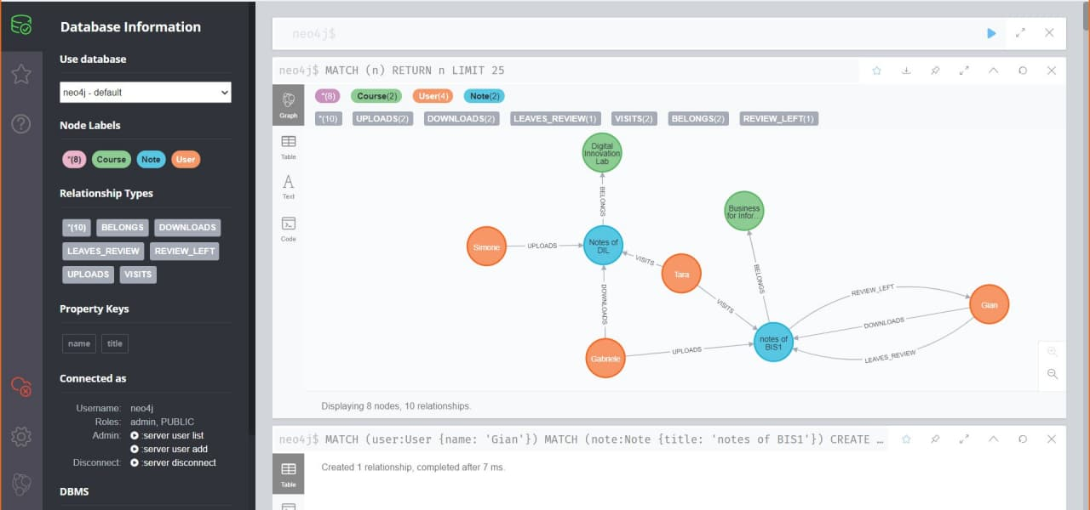

Some very basic Cypher queries for the creation of the graph database follows:

1. The query for obtaining the full database:

(The LIMIT has been set to 25 for simplicity, since the number of nodes is lower than 25)

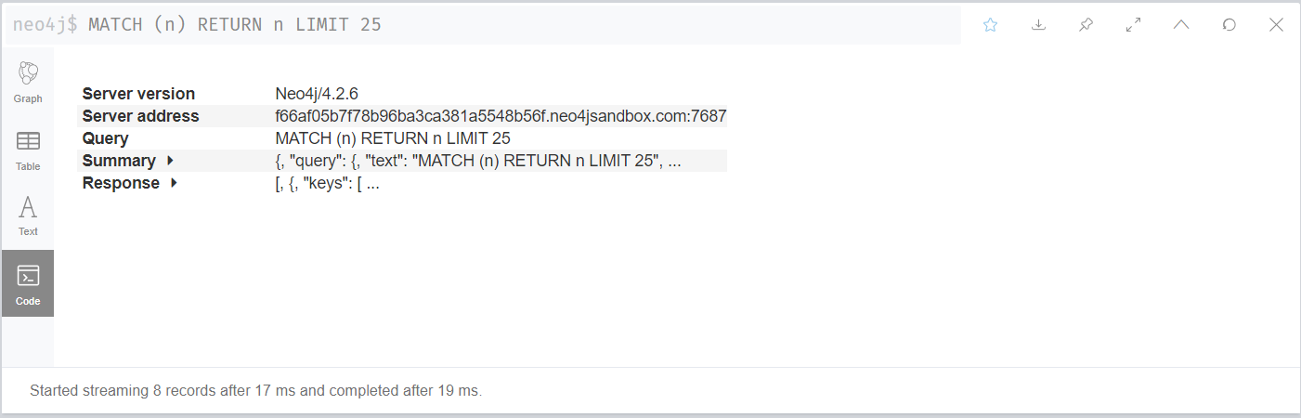

1. The query for creating a node:

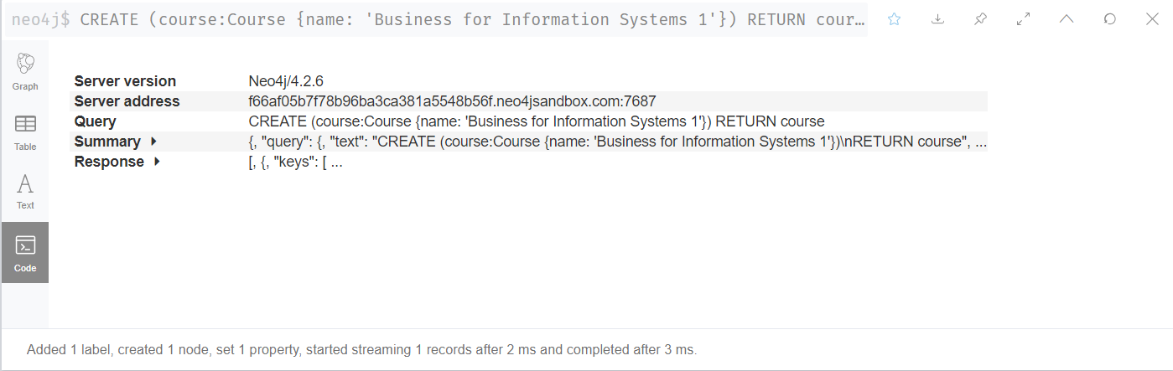

1. The query for creating a relationship between two nodes:

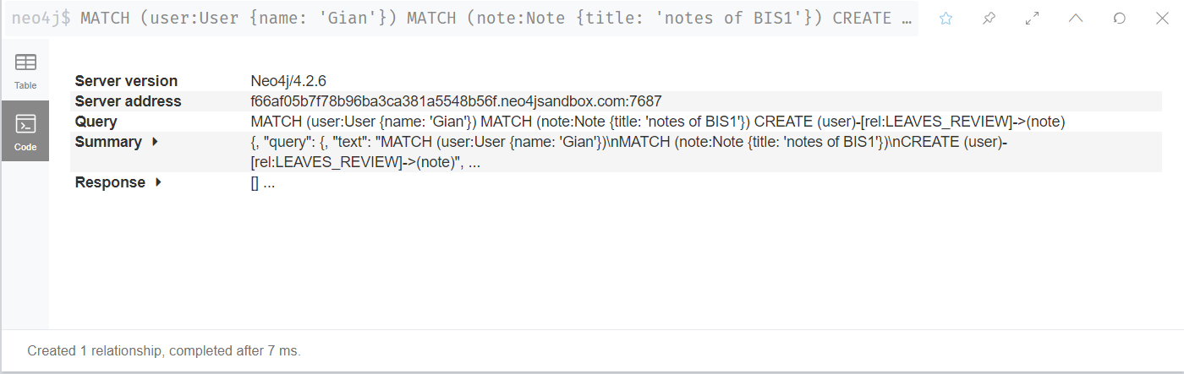

Then, to go further in detail in the implementation of the Graph database, we’ve chosen to implement it by inserting an amount of data which permits us to simulate a real case scenario.

The full database has become:

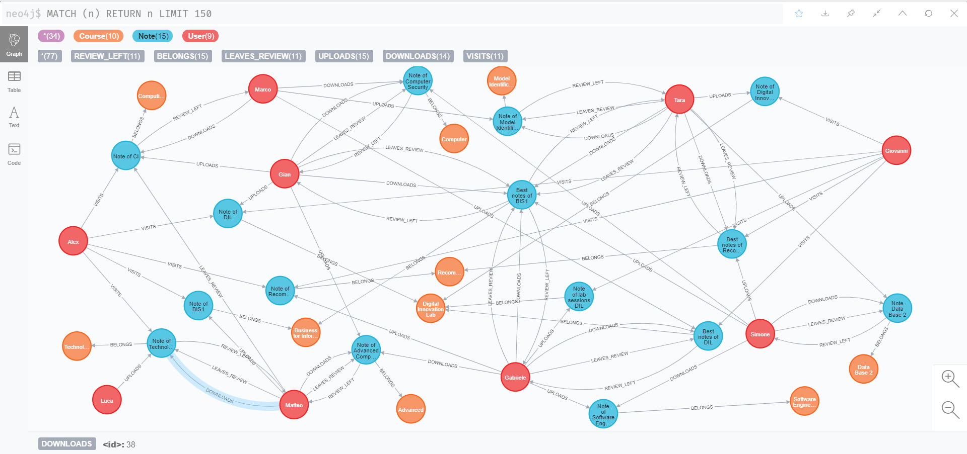

Besides, we’ve written the most significant Cypher queries for our application:

1. This query shows all the names of the “notes” which belongs to a particular “course”:

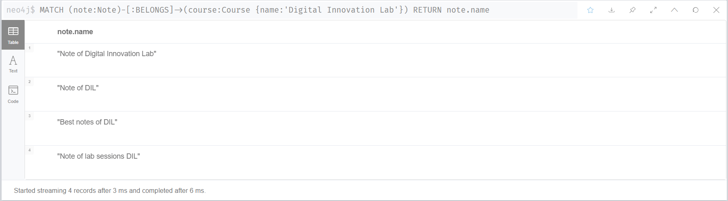

1. This query shows all the names of the “notes” which have been downloaded by a particular “user”:

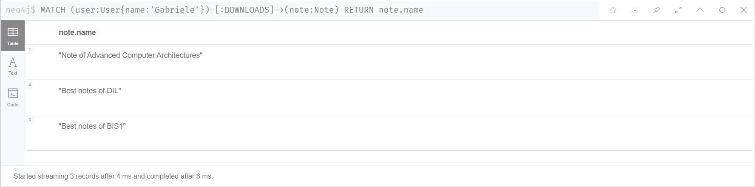

1. This query shows all the names of the “notes” which have been uploaded by a particular “user”: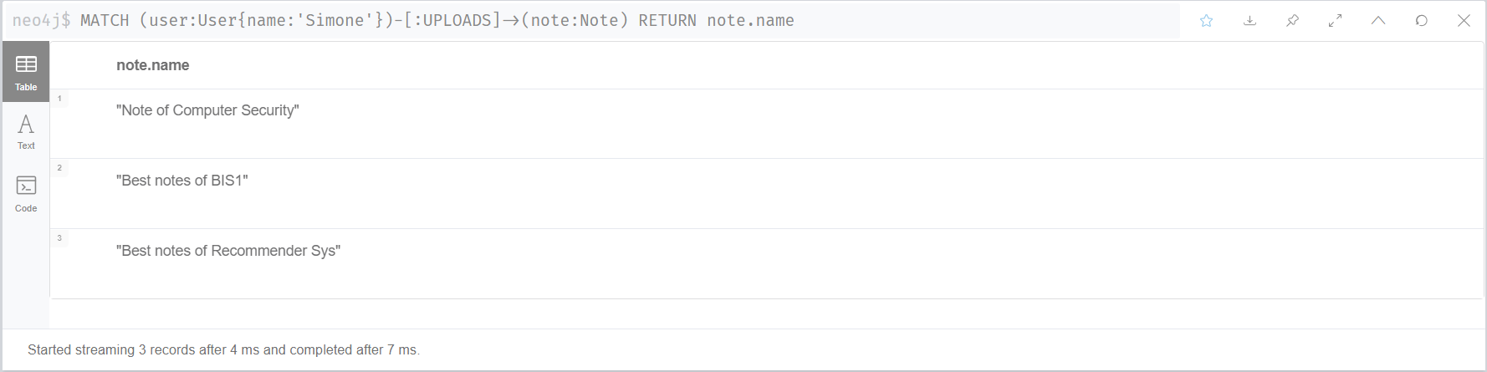
2. This query shows all the names of the “users” who left a review for a particular “note”:

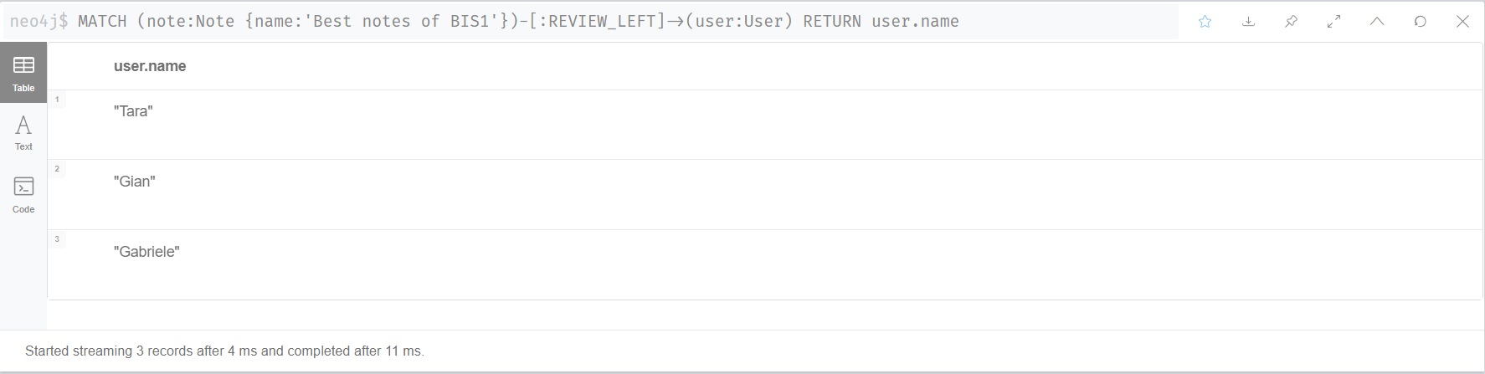

1. This query shows all the names of the “users” that after having downloaded a particular “note”, haven’t left a review.

(The warning in this query is about the fact that the query contains a cartesian product between two disconnected patterns; however, this is intentionally intended for what we want to obtain.)

